Name

Mathematics Stage 4
Indices

Book 1 | Index notation and divisibility  Square and cube roots  Index laws | Version: 260706  Feedback:  https://MrDingMaths.com
Contents
Index Notation 5
Evaluate Expressions with Indices 11
Divisibility 18
Prime Numbers 24
Prime Factorisation 25
Square Roots 34
Cube Roots 40
Evaluate Expressions with Roots 45
Index Law of Multiplication 50
Index Law of Division 52
Index Law of Power of a Power 54
Index Law of Zero Power 57
Mixed Practice 59
Evaluating Expressions by Applying Index Laws 66
HCF and LCM using Prime Factorisation 71
Challenge Exercise 76

Syllabus Content
MA4-INT-C-01 operates with primes and roots, positive-integer and zero indices involving numerical bases and establishes the relevant index laws
Apply index notation to represent whole numbers as products of powers of prime numbers
- Describe numbers written in index form using terms such as base, power, index and exponent
- Represent numbers in index notation limited to positive powers
- Represent in expanded form and evaluate numbers expressed in index notation, including powers of 10
- Apply the order of operations to evaluate expressions involving indices
- Determine and apply tests for divisibility for 2, 3, 4, 5, 6 and 10
- Represent a whole number greater than one as a product of its prime factors, using index notation where appropriate
Examine cube roots and square roots
- Use the notations for square root () and cube root ($\sqrt[3]{}$)
- Recognise and describe the relationship between squares and square roots, and cubes and cube roots for positive numbers
- Verify, through numerical examples, that $\sqrt{ab}=\sqrt{a}×\sqrt{b}$
- Estimate the square root of any non-square whole number and the cube root of any non-cube whole number, then check using a calculator
- Identify and describe exact and approximate solutions in the context of square roots and cube roots
- Apply the order of operations to evaluate expressions involving square roots, cube roots, square numbers and cube numbers
Use index notation to establish the index laws with positive-integer indices and the zero index
- Establish the multiplication, division and the power of a power index laws, by expressing each number in expanded form with numerical bases and positive-integer indices
- Verify through numerical examples that ${\left(ab\right)}^{2}=a^{2}b^{2}$
- Establish the meaning of the zero index
- Apply index laws to simplify and evaluate expressions with numerical bases

Index Notation

- Index Notation
- Powers show repeated multiplication.
- $8^{3}$ is read: ‘8 to the power of 3’
- We call 8 the base and 3 the power, or index.
- Any number without a power has a power of 1.
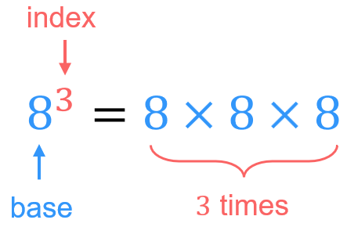
- “index”, “power”, “exponent” all mean the same thing.

- Rewrite repeated multiplication in index form
Write these numbers in index form.
- $5×5×5×5×5×5=5^{6}$ | - $2×2×2×2×2×2=2^{6}$
- $13×13×13×13×13×13$ | - $3×3×3×3×3$
- $5×5×5×5$ | - 6
- $\left(2×2×2\right)×\left(3×3×3×3\right)=2^{3}×3^{4}$ | - $4×4×4×5×5$
- $5×2×2×2×3×3×5$ | - $3×2×2×3×3$

- Rewrite Index form in expanded form
Write these numbers in expanded form.
- $2^{4}$  $$=2×2×2×2$$ | - $2^{3}×3^{5}$  $$=(2×2×2)×(3×3×3×3×3)$$
- $3^{6}$ | - ${13}^{4}$
- $2^{3}×{14}^{5}$ | - $6^{5}×{\left(\frac{2}{3}\right)}^{3}$

- Example Evaluate numbers in index form
$3^{2}$  $=3×3$  $=9$ | $2^{5}$  $=2×2×2×2×2$  $=32$

- Guided Practice
Evaluate:
- $2^{3}$ | - $2^{6}$
- $7^{3}$ | - ${10}^{4}$

- Key Ideas
- Powers represent repeated ……………………
- $7^{5}$: ………… is the base number and ……… is the index number.
- We can also call the index number the ………………… or the ……………………
- We read out $7^{5}$ as “7 to the ……………… of 5”

Foundation
- Complete the table:
Index Form | Expanded Form | Basic Numeral
$$2^{3}$$ | $$2×2×2$$ | $$8$$
$$5^{2}$$ | $$5×5$$ | $$25$$
$${10}^{3}$$ | $$10×10×10$$ | 1000
$$2^{6}$$ | $$2×2×2×2×2×2$$ | 64
$$3^{9}$$ | $$3×3×3×3×3×3×3×3×3$$ | 19683
$$6^{2}$$ | $6×6$ | 36
$$4^{3}$$ | $4×4×4$ | 64
$$2^{5}$$ | $2×2×2×2×2$ | 32
$$3^{4}$$ | $3×3×3×3$ | 81
$$1^{500}$$ | $$1×1×1×1×…(500 times)$$ | 1
$$0^{500}$$ | $$0×0×0×0×…(500 times)$$ | 0

- Evaluate these expressions.
- $4^{3}$  64 | - $2^{5}$  32
- $3^{4}$  81 | - $5^{2}$  25
- $2^{4}$  16 | - ${(-5)}^{2}$  25
- $1^{4}$  1 | - ${\left(-5\right)}^{3}$  $-$125
- $0^{4}$  0 | - ${\left(0.2\right)}^{2}$  $$0.04$$
- $1^{412}$  1 | - ${\left(0.2\right)}^{3}$  $$0.008$$
- ${412}^{1}$  412 | - ${\left(\frac{1}{5}\right)}^{3}$  $$\frac{1}{125}$$
- ${\left(-412\right)}^{1}$
$$-412$$

Development
- Simplify the following expressions by writing them with powers.
- $3×3×5×5$  $$3^{2}×5^{2}$$ | - $10×9×10×9×9×7$  $$7×9^{3}×{10}^{2}$$
- $8×8×5×5×5$  $$8^{2}×5^{3}$$ | - $\left(-2\right)×(-2)$  $${\left(-2\right)}^{2}$$
- $8×8×8×11×11$  $$8^{3}×{11}^{2}$$ | - $\left(-1\right)×\left(-1\right)×(-1)$  $${\left(-1\right)}^{3}$$
- $7×7×2×2×7$  $$2^{2}×7^{3}$$ | - $\frac{3}{7}×\frac{3}{7}×\frac{3}{7}$  $${\left(\frac{3}{7}\right)}^{3}$$
- $12×9×9×12$  $$9^{2}×{12}^{2}$$ | - $\frac{7}{4}×\frac{7}{4}×\frac{7}{4}×\frac{7}{4}$  $${\left(\frac{7}{4}\right)}^{4}$$
- $6×3×6×3×6×3$  $$3^{3}×6^{3}$$ | - $2^{5}×2$  $$2^{6}$$
- $13×7×13×7×7×7$  $$7^{4}×{13}^{2}$$ | - $x×x×x×x×x$  $$x^{5}$$
- $4×13×4×4×7$  $$4^{3}×7×13$$ | - $a×b×a×b×a×c$  $$a^{3}b^{2}c$$

- Write these expressions in expanded form.
- $3^{5}×2^{3}$  $$3×3×3×3×3×2×2×2$$ | - $4^{5}×9^{3}$  $$4×4×4×4×4×9×9×9$$
- $7^{2}×5^{3}$  $$7×7×5×5×5$$ | - $a^{2}×b^{3}$  $$a×a×b×b×b$$
- $4^{3}×3^{4}$  $$4×4×4×3×3×3×3$$ | - $2^{2}×c^{3}$  $$2×2×c×c×c$$

- There is a disease where the number of people infected doubles each day.
Complete the first row of the table before completing the second row.
 | Day 0 | Day 1 | Day 2 | Day 3 | Day 4 | Day 5
People Infected | 1 | $$2$$ | $$2×2$$ | $$2×2×2$$ | $$2×2×2×2$$ | $$2×2×2×2×2$$
Index Notation | $$2^{0}$$ | $$2^{1}$$ | $$2^{2}$$ | $$2^{3}$$ | $$2^{4}$$ | $$2^{5}$$

  - How many people would be infected on day 40, in index form?
$$2^{40}$$
  - If it takes 32 days for half the population of Earth to be infected, how many days will it take for the entire population to be infected?
33

- Write each of these as a power of 10.
- $10×10×10$  $${10}^{3}$$ | - $10×10×10×10×10$  $${10}^{5}$$ | - $10×10$  $${10}^{2}$$
- $100$  $${10}^{2}$$ | - $1000$  $${10}^{3}$$ | - $10 000$  $${10}^{4}$$
- $10 000 000$  $${10}^{7}$$ | - 1 million (6 zeros)  $${10}^{6}$$ | - $100 000 000$  $${10}^{8}$$
- $10 000 000 000$  $${10}^{10}$$ | - 1 billion (9 zeros)  $${10}^{9}$$ | - 100 billion  $${10}^{11}$$

- Evaluate these expressions.
$$9$$ | $$49$$ | $$81$$ | $144$
$$9$$ | $$49$$ | $$81$$ | $$144$$

- Work out the following:
- ${\left(-1\right)}^{1}$  $$-1$$ | - ${\left(-1\right)}^{2}$  1 | - ${\left(-1\right)}^{3}$  $$-1$$ | - ${\left(-1\right)}^{4}$  1 | - ${\left(-1\right)}^{5}$  $$-1$$
- ${\left(-2\right)}^{1}$  $$-2$$ | - ${\left(-2\right)}^{2}$  4 | - ${\left(-2\right)}^{3}$  $$-8$$ | - ${\left(-2\right)}^{4}$  16 | - ${\left(-2\right)}^{5}$  $$-32$$
- ${\left(-3\right)}^{1}$  $$-3$$ | - ${\left(-3\right)}^{2}$  9 | - ${\left(-3\right)}^{3}$  $$-27$$ | - ${\left(-3\right)}^{4}$  81 | - ${\left(-3\right)}^{5}$  $$-243$$

Using the above, complete these sentences:
A negative number raised to an odd power is
negative
A negative number raised to an even power is
positive
Decide whether the answer to each calculation will be positive or negative. You do not need to work out the answers
- ${\left(-9\right)}^{24}$  positive | - ${\left(5\right)}^{19}$  positive | - ${\left(-1\right)}^{11}$  negative | - ${\left(-200\right)}^{298}$  positive

Mastery
- Rewrite each number in expanded form with powers of 10. The first one has been done for you.
- $537$  $$=500+30+7$$  $=5×{10}^{2}+3×{10}^{1}+7$ | - 38  $$3×{10}^{1}+8$$ | - 798  $$7×{10}^{2}+9×{10}^{1}+8$$
- $1235$  $$1×{10}^{3}+2×{10}^{2}+3×{10}^{1}+5$$ | - 306  $$3×{10}^{2}+6$$ | - 40007  $$4×{10}^{4}+7$$
- $8 000 500$  $$8×{10}^{6}+5×{10}^{2}$$ | - 94 400 000  $$9×{10}^{7}+4×{10}^{6}+4×{10}^{5}$$ | - 4 350 000 000  $$4×{10}^{9}+3×{10}^{8}+5×{10}^{7}$$

- Rewrite each number as a basic numeral.
- $7×{10}^{1}$  70 | - $3×{10}^{2}+6×{10}^{1}+4$  364 | - $9×{10}^{2}+8×{10}^{1}$  980
- $7×{10}^{6}+3×{10}^{4}$  7 030 000 | - $6×{10}^{5}+3×{10}^{2}+5$  600 305 | - $8×{10}^{9}+3×{10}^{6}$  8 003 000 000

- Find the missing digits.
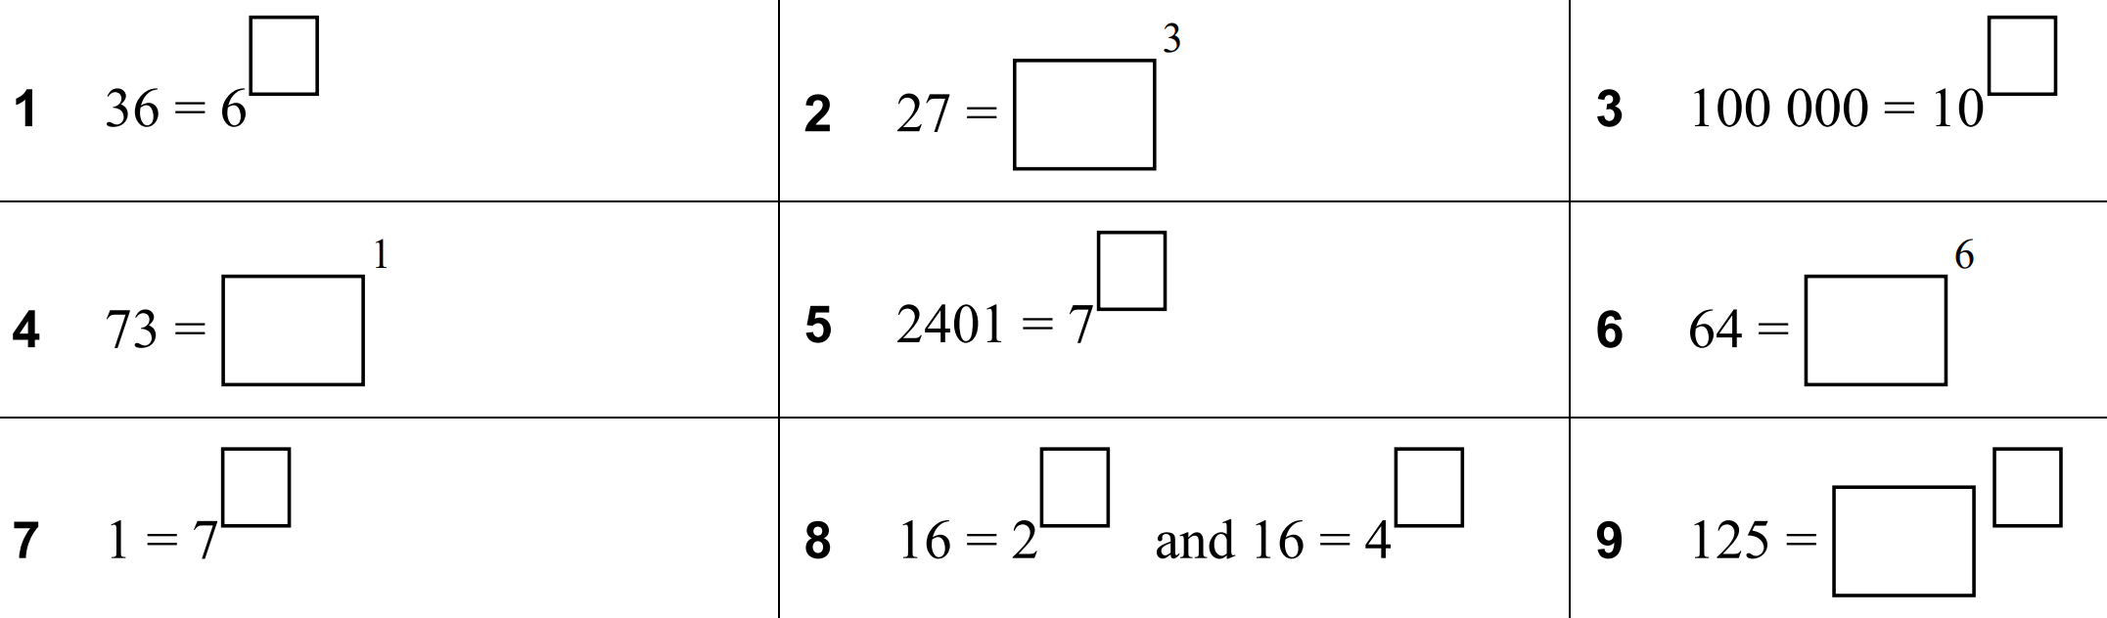  2 | 3 | 5
73 | 4 | 2
2 | 4 | $$5^{3}$$

Evaluate Expressions with Indices

- Review
- Evaluate using the order of operations
- $5+2×3$ | - $4×2+3×5$ | - $8-2×3$
- $2+4×3÷6$ | - $13-3×4+2$ | - $3+4×(10-7)$
- $60÷\left(5×2\right)+3$ | - $\left(5×10\right)÷(5×5)$ | - $\left(3×8-6×2\right)÷4$
- $\frac{1+3×4}{2}$ | - $13-\left(\left(4+6\right)÷2\right)$ | - $\frac{10×3+2}{4}$

- Order of Operations
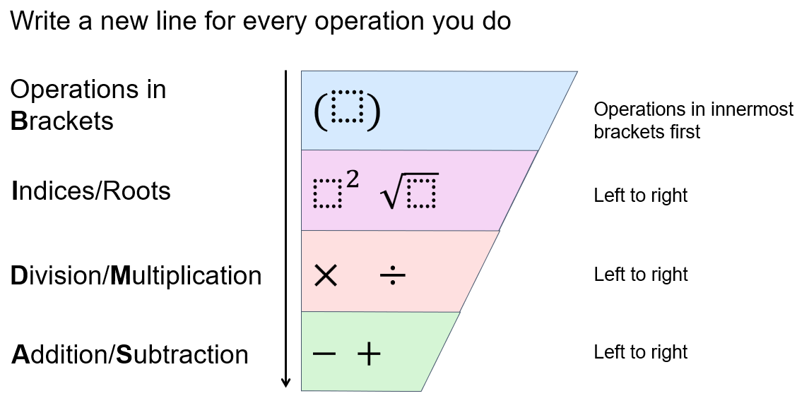

- Example Evaluate expressions with indices
$7^{2}-6^{2}$  $=49-36$  $=13$ | $\left(2+3^{3}\right)×10^{2}$  $=\left(2+27\right)×{10}^{2}$  $=29×{10}^{2}$  $=29×100$  $=2900$

- Guided Practice
Evaluate:
- $5^{3}-2^{4}$  109 | - $3^{4}+7^{2}$  130
- $6^{2}-4^{3}÷2$  4 | - $2+3^{2}×4$  38
- $6×(1+3^{2})$  60 | - ${\left(5+2\right)}^{2}÷9$  $$\frac{49}{9}$$

Foundation
- Evaluate these expressions.
7 | 1 | 22
5.5 | 0.75 | 13

- Evaluate these expressions.
21 | 29 | 81 | 41

- Evaluate these expressions.
- $3^{2}+4^{2}$  $=9+16$  $=$ ……………  25 | - $2×5^{2}-7^{2}$  $=2×25-49$  $=$ ……………  1 | - $8^{2}-2×3^{3}$  10
- $3{\left(9-5\right)}^{2}$  48 | - $2^{4}×2^{3}$  128 | - $1^{4}×2^{3}+3^{2}+4$  21
- ${10}^{3}-{10}^{2}$  900 | - $2.57×{10}^{4}$  25 700 | - $1^{512961}-1^{595718}$  0

- Evaluate these expressions.
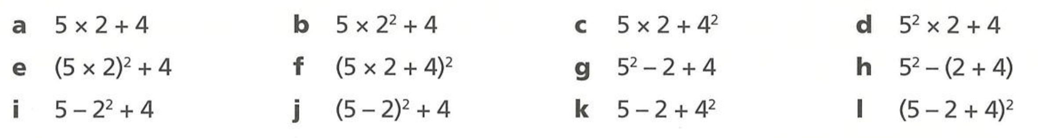  14 | 24 | 26 | 54
104 | 196 | 27 | 19
5 | 13 | 19 | 49

- Evaluate these expressions.
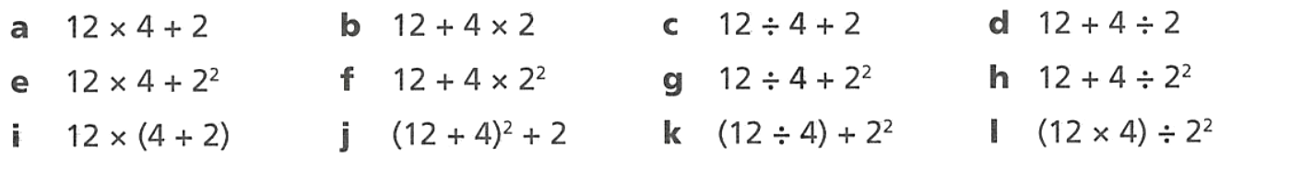  50 | 20 | 5 | 14
52 | 28 | 7 | 13
72 | 258 | 7 | 12

Development
- Read the examples carefully and answer the questions.
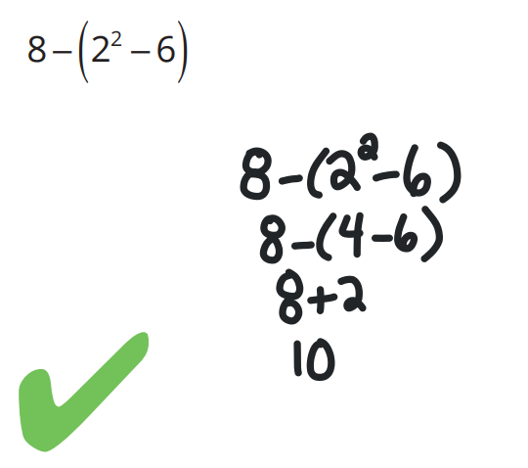  Helen’s work: | Which operation did Helen do first, and why?  The square, as it was an index operation inside brackets.  Why did she write +2 in her third line?  Sne skipped a step $8-\left(-2\right)$, which simplifies to $8+2$  Evaluate:  $$8+(3^{2}-12)$$  5
Morgan’s work:  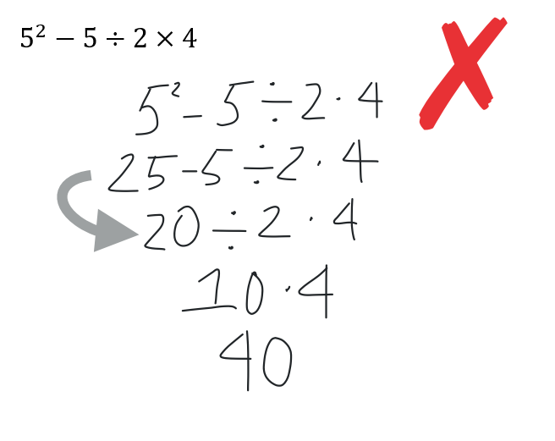 | In the step marked with an arrow, Morgan subtracted. What operation should she have done instead of subtraction?  division  Evaluate:  $$5^{2}+6÷2×4$$  37
John’s work:  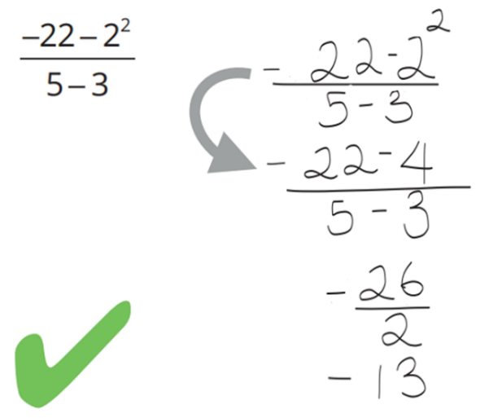 | Explain how John used the order of operations to do the step marked with an arrow correctly.  He did the square first.  Evaluate:  $$\frac{-22+2^{2}}{5-3}$$  $$-9$$

- Evaluate the following.
- $4+2×3^{2}$  22 | - ${\left(4+2-3\right)}^{2}$  9 | - $\left(4+2\right)×3^{2}$  54 | - $4+{\left(2-3\right)}^{2}$  5
- $4+{\left(2×3\right)}^{2}$  40 | - $4×{\left(2-3\right)}^{2}$  4 | - ${\left(4+2×3\right)}^{2}$  100 | - ${\left(4×2-3\right)}^{2}$  25

- Determine the index number for these basic numerals.
4 | 2 | 3 | 6
3 | 2 | 2 | 4

- Write 32 as the sum of two indices.

$2^{4}+2^{4}$, many answers possible
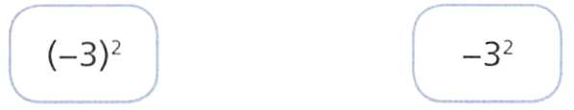
- Evaluate the expression on each card.

What's different about these questions and answers?

$${\left(-3\right)}^{2}=9,$$
$$-3^{2}=-9$$
- Find possible integers such that:
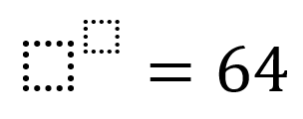

$$2^{6}, 4^{3}, 8^{2}, {64}^{1}$$

Mastery
- There are 100 rabbits on Mt Burrow at the start of the year 2000. The rule for the number of rabbits $N$ after $t$ years (from the start of the year 2000) is $N = 100 × 2^{t}$.
  - Find the number of rabbits at:
    - $t=2$
400
    - $t=6$
6400
    - The beginning of 2007
12 800
    - The beginning of 2010
102 400
  - How many years will it take for the population to first rise to more than 500 000?
Give a whole number of years.
13 years

- Using guess and check, find the missing number.
7 | 3 | 7 | 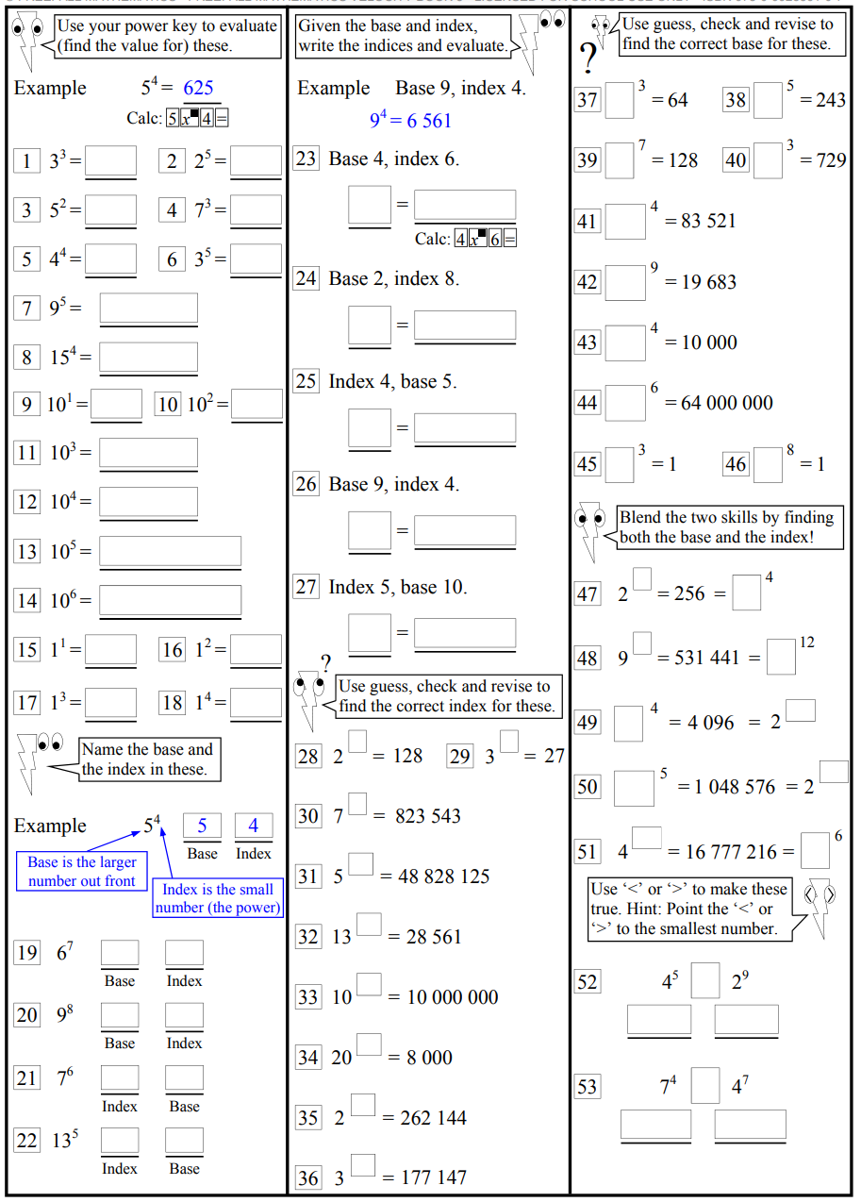  3
4 | 3 | 2 | 10
1 | 1 | 8, 4

- Given that ${12}^{5}=248 832$, what is the value of ${\left(-12\right)}^{5}$? Explain how you know.

$-248832$, since a negative number raised to an odd power is negative.
- $x^{2}=564$. What is the value of ${\left(-x\right)}^{2}$? Explain how you know.

564, a negative number raised to an even power is positive.
- Follow the order of operations to evaluate each expression.
- ${\left(7-10\right)}^{3}+21÷ -7$  $$-30$$ | - ${\left(-5\right)}^{2} × 6 ÷ \left[10 × 5 ÷ \left(-10\right)\right]$  $$-30$$

Divisibility

- Divisibility Tests
Use the divisibility tests to test whether a number is a factor of another number.

Divisible by | Test
2 | The last digit is even (0, 2, 4 , 6 or 8).
3 | The sum of the digits is divisible by 3.
4 | The last two digits are divisible by 4.
5 | The last digit is 5 or 0.
6 | The number is divisible by 2 and 3.
10 | The last digit is 0.

- Apply the divisibility tests
Number | $÷$2 | $÷$3 | $÷$4 | $÷$5 | $÷$6 | $÷$10
2022 | ✔ | ✔ | ✖ | ✖ | ✔ | ✖

Number | $÷$2 | $÷$3 | $÷$4 | $÷$5 | $÷$6 | $÷$10
196

Number | $÷$2 | $÷$3 | $÷$4 | $÷$5 | $÷$6 | $÷$10
3000

Number | $÷$2 | $÷$3 | $÷$4 | $÷$5 | $÷$6 | $÷$10
135

Foundation
- Circle the numbers that are divisible by 2.
- 28 | - 1003 | - 27
- 66 | - 59 691 | - 185
- 1112 | - 80 000 | - 77 772
a, d, g, h, i
- Circle the numbers that are divisible by 4.
- 42 | - 50 | - 148
- 86 | - 532 | - 102
- 5794 | - 44 448 | - 13 212
- 30 006 | - 91 428 | - 10 100
c,e, h, i, k, l
- The final digit of these numbers is missing. These numbers are divisible by 5.
Write two possible final digits.
- 3… 3…  0, 5 | - 9… 9…  0, 5 | - 15… 15…  0, 5 | - 21… 21…  0, 5
- 21… 21…  0, 5 | - 100… 100…  0, 5 | - 86… 86…  0, 5 | - 917… 907…  0, 5

- Circle the numbers that are divisible by 10.
- 90 | - 643 | - 10 101
- 3804 | - 13 330 | - 80800
a, e, f

- Test these for divisibility by 2, 4, 5 and 10. Shade in the circle if it is divisible.
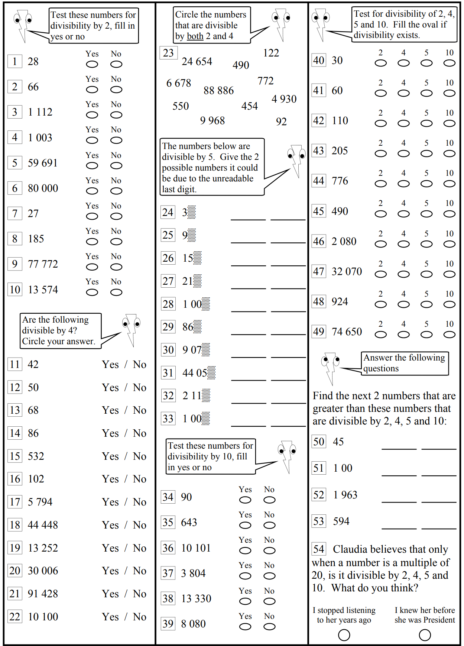  2, 5, 10 | 5 | 2, 4, 5, 10
2, 4, 5, 10 | 2, 4 | 2, 5, 10
2, 5, 10 | 2, 5, 10 | 2, 4

- True or false? Every number divisible by 10 is also divisible by 2 and 5.

True
- Test whether these numbers are divisible by 3. Sum the digits, then decide.
Number | Sum of Digits | Divisible by 3? |  | Number | Sum of Digits | Divisible by 3?
- 8022 | 12 | yes |  | - 8301 | 12 | yes
- 78 | 15 | yes |  | - 10 020 | 3 | yes
- 93 | 12 | yes |  | - 84 355 | 25 | no
- 112 | 4 | no |  | - 99 996 | 42 | yes
- 108 | 9 | yes |  | - 17 361 | 18 | yes
- 108 00 | 9 | yes |  | - 44 004 | 12 | yes
- 3419 | 17 | no |  | - 14 053 | 13 | no
- 77 322 | 21 | yes |  | - 8931 | 21 | yes

- Test whether these numbers are divisible by 6.
First decide if its divisible by 2, then decide if its divisible by 3.
Number | Divisible by 2? | Sum of Digits | Divisible by 3? | Divisible by 6?
- 38 | Yes | 11 | No | No
- 96 | Yes | 15 | Yes | Yes
- 578 | Yes | 20 | No | No
- 690 | Yes | 15 | Yes | Yes
- 1809 | No | 18 | Yes | No
- 8931 | No | 21 | Yes | No
- 14 053 | No | 13 | No | No
- 35 730 | Yes | 18 | Yes | Yes

Development
- Which of these numbers have a factor of 2? (circle)

a, c, d
- Which of these numbers have a factor of 3? (circle)

b, d
- Which of these numbers have a factor of 4? (circle)

a, d
- Which of these numbers have a factor of 5? (circle)

a, b
- Which of these numbers have a factor of 6? (circle)

a, c
- Which of these numbers have a factor of 10? (circle)

b, d
- Complete these divisibility tables.
 | Divisible by
Number | $÷$2 | $÷$3 | $÷$4 | $÷$5 | $÷$6 | $÷$10
60 | Y | Y | Y | Y | Y | Y
2 016 | Y | Y | Y | N | Y | N
243 567 | N | Y | N | N | N | N
28 080 | Y | Y | Y | Y | Y | Y
189 000 | Y | Y | Y | Y | Y | Y
1 308 150 | Y | Y | N | Y | Y | Y

- Determine which of the following calculations are possible without leaving a remainder
(answer Yes or No).
- 23562 ÷ 3  Y | - 39245678 ÷ 4  N
- 3193457 ÷ 6  N | - 2000340 ÷ 10  Y
- 51345678 ÷ 5  N | - 215364 ÷ 6  Y
- 9543 ÷ 6  N | - 25756 ÷ 2  Y
- 324534565 ÷ 5  Y | - 329541 ÷ 10  N
- 225329 ÷ 3  N | - 2002002002 ÷ 4  N

- Explain why a number not divisible by 2 would also not be divisible by 4.

The number must be odd, no odd number is divisible by an even number.
- Explain why a number divisible by 2 and 3 must also be divisible by 6.

The lowest common multiple of 2 and 3 is 6.
- Emily says that a number divisible by 24 must also be divisible by 4 and 6.
Explain why she is correct.

4 and 6 are factors of 24.
- Emily says a number divisible by 4 and 6 must also be divisible by 24.
  - Give an example to show she is incorrect.

The lowest common multiple of 4 and 6 is not 24. 12 is divisible by 4 and 6, but not 24.
  - We need to pick two numbers that are coprime (do not have any common factors).
If a number is divisible by …… and ……, it must be divisible by 24
3 and 8
  - If we want to test divisibility by 18, we would test for …… and ……
2, 9
  - If we want to test divisibility by 45, we would test for …… and ……
5, 9
  - If we want to test divisibility by 60, we would test for …… and ……
5, 12
4, 15
3, 20
- How many of the whole numbers between 1 and 250 inclusive are not divisible by 5?
Explain, in written form, how you arrived at your answer.

There are 250 $÷$ 5 = 50 multiples of 5 between 1 and 250. Therefore, there are 200 not divisible by 5.

Mastery

  - Explain why Julie cannot share $41.75 equally among her three children.

The sum of the digits is 17, which is not divisible by 3.
  - What is the smallest amount of money Julie needs to add to $41.75 to be able to share it amongst her three children?

1 cent. That would make sum of digits 18, which is divisible by 3.
- Is the number 968 362 396 392 139 963 359 divisible by 3?

yes
Which digits in the number could you ignore, and why?
(Hint: you only need to consider five digits)

You can ignore any multiple of 3, since the sum of multiples of 3 are divisible by 3.
- How many two-digit numbers are divisible by 2 and 3? Explain how you arrived at your answer.

How many 2 digit numbers are divisible by 6? 15
- Find the largest three-digit number that is divisible by both 4 and 5.
Explain how you arrived at your answer.

4 and 5 have a LCM of 20. The largest multiple of 20 less than 1000 is 980.
- Blake’s age is a two-digit number. It is divisible by 2, 3, 6 and 9.
How old is Blake if you know that he is older than 20 but younger than 50?

LCM is 2, 3, 6, 9 is 18.
Blake’s age must be a multiple of 18 between 20 and 50
Blake is 36

Prime Numbers

- Prime Numbers
Prime numbers  Only 2 factors.  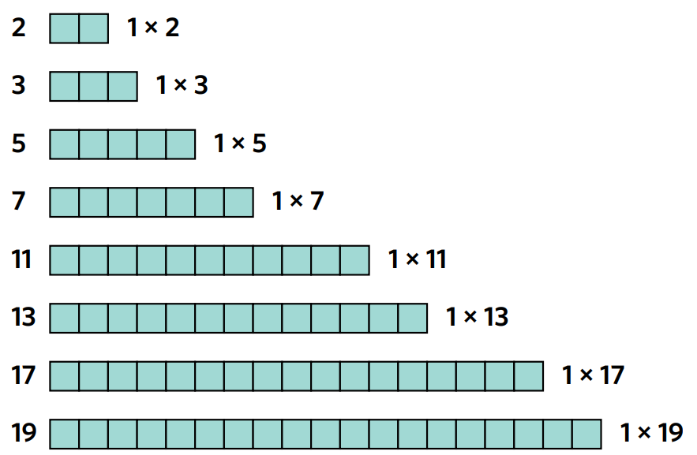  Can only form 1 row arrays | Composite numbers  More than 2 factors  Can form arrays in many ways  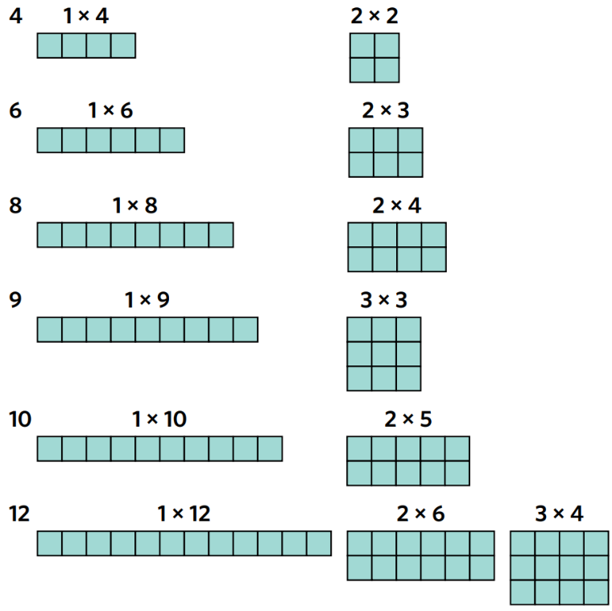
The first 10 prime numbers

1 is neither prime nor composite.

2, 3, 5, 7, 11, 13, 17, 19, 23, 29

- Identify Prime numbers
Decide whether these numbers are prime or composite. Use the divisibility tests if stuck.
- 2 | - 3 | - 4
- 14 | - 23 | - 70
- 51 | - 999 | - 37
- 172 549 172 | - 1 888 081 808 881

Prime Factorisation

- Fundamental Theorem of Arithmetic
We can represent any integer greater than 1 as a unique product of prime factors.
Prime factorisation breaks a number down into its prime factors.
- Prime Factorisation: https://www.geogebra.org/m/jvggnptq

- Identify Prime factorisation of a number
Write these numbers as a product of two or more prime numbers.
- 26  $$=2×13$$ | - 8 | - 10
- 16 | - 35 | - 17
- 25 | - 12 | - 54

- Key Ideas
- The fundamental theorem of arithmetic says that any integer greater than 1 can be written as a product of ……………… ………………
- There is only ……… way to write each number as a product of prime factors, so we call this unique.

- Factor Trees
- Factor Tree: https://www.geogebra.org/m/qg9uepm9
- A factor tree is useful for finding the prime factorisation of large numbers.
- Think of a factor pair and draw two branches with the two factors at the ends.
- If the factor is a prime number, then end or terminate the branch.
Move on to the other factor and repeat step 1.
- Once you have found all the prime factors, write them as a product from smallest to largest.
- Use index form to represent multiple prime factors.

- Example Write a number in prime factor form using a factor tree
Find the prime factorisation of 40.
$$40$$
4 |  |  |  | 10
2 |  |  | 2 | 2 |  |  | 5

$$40=2^{3}×5$$

- Guided Practice
Draw the factor tree for these numbers, then write its prime factorisation in index form.
$45=$ …… $×$ …… $×$ ……  $=$ …… $×$ …… | $150=$ …… $×$ …… $×$ …… $×$ ……  $=$ ……………………
  $$45$$
  9
  $$150$$
  15
- 60 | - 60 (another way)

Foundation
First 10 prime numbers:

- Complete these factor trees and write the number in prime factor form.
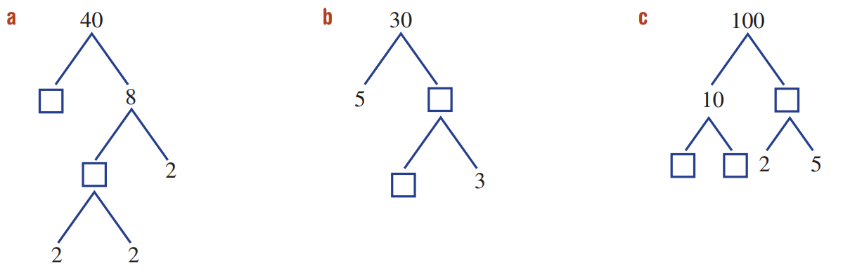  40 = $2×2×2×5$  = ………………  $$2^{3}×5$$ | 30 = ……………………….  …………………….…  $$2×3×5$$ | 100 = ………….…………  ………………….…  $$2^{2}×5^{2}$$

- Complete these factor trees and write the number as a product of its prime factors.
90 = …………………….…  …………………….…  $$2×3^{2}×5$$ | 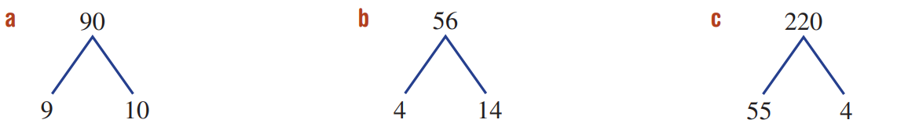  56 = ……………………….  …………………….…  $$2^{3}×7$$ | 220 = ………….…………  ………………….…  $$2^{2}×5×11$$

- A student is asked to express 70 as a product of its prime factors.
Explain why they are incorrect.
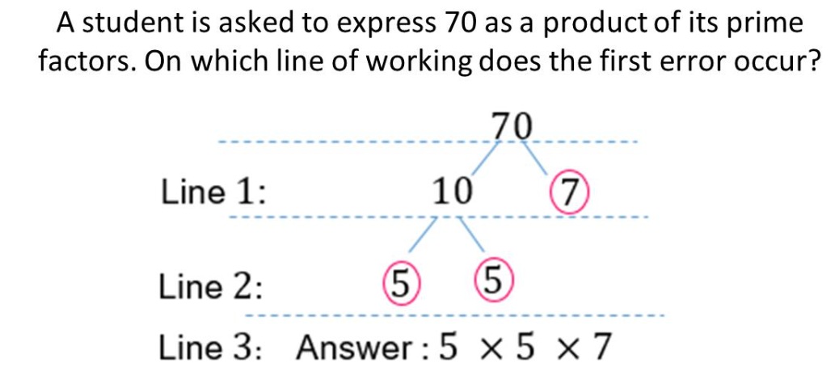
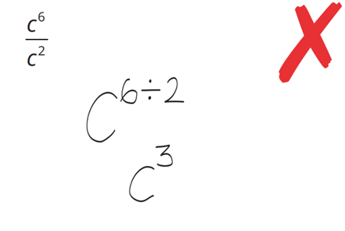

Prime factors of 10 are not 5 and 5, it is 2 and 5.
- Choose the correct factor tree for 21 and explain why the others are incorrect.
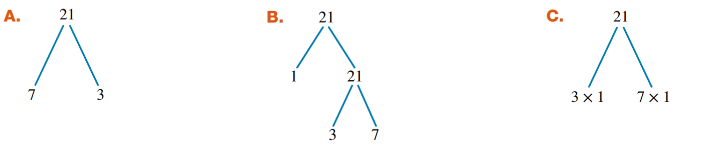

B and C are incorrect as 1 is not a prime number.
- Express the following numbers as products of its prime factors using index notation.
The divisibility rules will be useful.
- 72  72 = …………………….…  $$2^{3}×3^{2}$$ | - 24  24 = ……………………….  $$2^{3}×3$$ | - 38  38 = ………….…………  $$2×19$$
- 44  $$2^{2}×11$$ | - 124  $$2^{2}×31$$ | - 80  $$2^{4}×5$$
- 96  $$2^{5}×3$$ | - 240  $$2^{4}×3×5$$ | - 690  $$2×3×5×23$$

Development
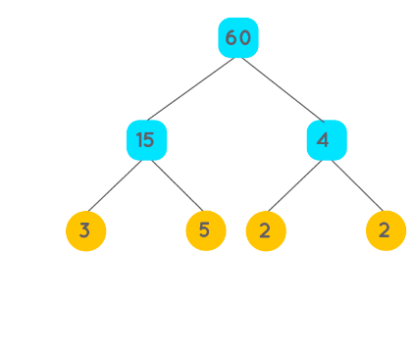
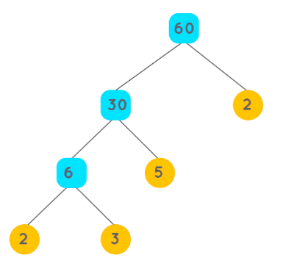
- Consider these two factor trees for 60, then complete the sentence.
$$2×3×5×2$$  $=2^{2}×3×5$ | $$3×5×2×2$$  $=$ ………………
There are …………… ways to draw a factor tree, but there is only ……… way to write the final prime factorisation. We say that a number’s prime factorisation is u……………
Many, one, unique
- Draw three different factor trees for 24. Show that the prime factorisation is unique. Note: simply swapping the order of a pair of factors does not qualify as a different factor tree.
24 | 24 | 24
$24=$ ………………………
$$2^{3}×3$$
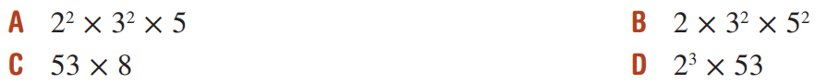
- Circle the correct prime factorisation for 424:

Explain why you can eliminate options A and B immediately.

424 is not divisible by 5.
Explain why C is not the correct answer:

- is not prime.

- Instead of a factor tree, we can use repeated division by prime numbers to find the factors:
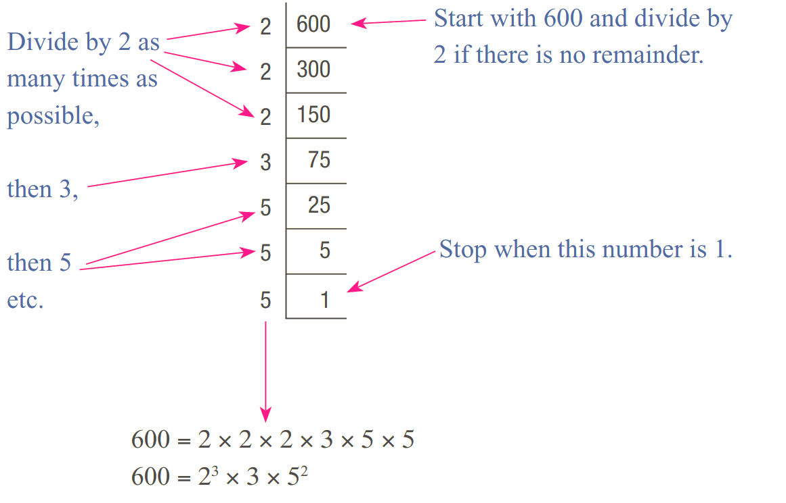

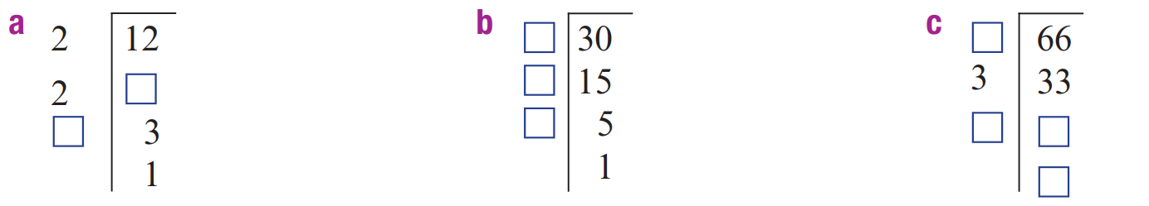  $$2^{2}×3$$ | $$2×3×5$$ | $$2×3×11$$
- 32  $$2^{5}$$ | - 40  $$2^{3}×5$$ | - 81  $$3^{4}$$
- 144  $$2^{4}×3^{2}$$ | - 500  $$2^{2}×5^{3}$$ | - 1250  $$2×5^{4}$$

Mastery
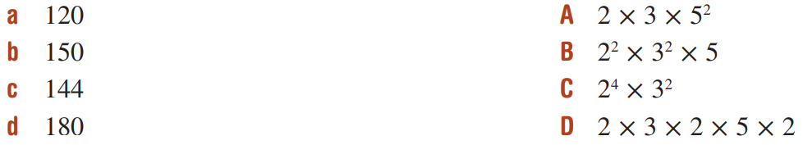
- Match the composite number to its prime factorisation.

a – D, b – A, c – C, d- B
- Answer True or False to the following:
  - $2$ is a factor of $2×3×7×13$ True | False
T
  - $3$ is a factor of $2×3×7×13$ True | False
T
  - $5$ is a factor of $2×3×7×13$ True | False
F
  - $7$ is a factor of $2×3×7×13$ True | False
T
  - $4$ is a factor of $2×3×7×13$ True | False
F
  - $6$ is a factor of $2×3×7×13$ True | False
T
  - $14$ is a factor of $2×3×7×13$ True | False
T
  - $21$ is a factor of $2×3×7×13$ True | False
T
  - $15$ is a factor of $2×3×7×13$ True | False
F
  - $15$ is a factor of $2×3×5×7×13$ True | False
T
  - $30$ is a factor of$2×3×5×7×13$ True | False
T
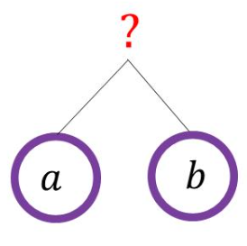
- $a$ and $b$ are different numbers. The factor tree is completed.
Which of these numbers could the tree be factorising? (circle one)
- 45 | - 47 | - 49 | - 51
D
Explain your answer.

51 is the only number that can be written as 2 different prime factors (3 and 17).

- Answer these questions using the given facts.
- $6=2×3$  What is 30 as the product of its prime factors?  $$2×3×5$$ | - $450=2×3^{2}×5^{2}$  What is 900 as its product of prime factors?  $$2^{2}×3^{2}×5^{2}$$ | - ${12=2}^{2}×3$  What is 36 as its product of prime factors?  $$2^{2}×3^{2}$$

- Answer these questions using the given facts.
- If $21=3×7$  What is 84 as the product of its prime factors?  $$2^{2}×3×7$$ | - if $1575=3^{2}×5^{2}×7$  What is 15750 as product of prime factors?  $$2×3^{2}×5^{3}×7$$ | - if $539=7^{2}×11$  What is 1617 as the product of prime factors?  $$3×7^{2}×11$$

- Fill in the gaps in the prime factorisation, given the information about the factors of the number.
  - $2^{3}×3×$ ……… $×$ ……… has factors of 14 and 15
5, 7
  - $2^{2}×3×$ ……… $×$ ……… has factors of 100 and 130
$$5^{2}, 13$$
  - $2^{2}×5×$ ……… $×$ ……… has factors of 12, 20, 27, and 28
$$3^{3}, 7$$
- It is possible to factorise a number already in index form:
$${10}^{3}={\left(2×5\right)}^{3}$$
$=\left(2×5\right)×\left(2×5\right)×(2×5)$
$=2^{3}×5^{3}$
Factorise the following:
- $6^{5}$  $$2^{5}×3^{5}$$ | - ${21}^{100}$  $$3^{100}×7^{100}$$ | - ${15}^{15}$  $$3^{15}×5^{15}$$

- We will use prime factors to investigate which fractions become recurring decimals.
Reminder: $\frac{1}{2}$ $=0.5$ (terminating decimal) $\frac{1}{3}$ $=0.\dot{3}$ (recurring decimal)
  - Use a calculator to convert these fractions to decimals, then list the prime factors of each denominator.
- $\frac{3}{20}$  Decimal:  $0.15$  Prime factors:  2, 5 | - $\frac{79}{80}$  Decimal:  0.9875  Prime factors:  2, 5 | - $\frac{17}{32}$  Decimal:  0.53125  Prime factors:  2 | - $\frac{18}{25}$  Decimal:  0.72  Prime factors:  5

  - Use a calculator to convert these fractions to decimals, then list the prime factors of each denominator.
- $\frac{7}{12}$  Decimal:  $$0.58\dot{3}$$  Prime factors:  2,3 | - $\frac{19}{30}$  Decimal:  $$0.6\dot{3}$$  Prime factors:  2, 3, 5 | - $\frac{11}{14}$  Decimal:  $$0.7\overline{857142}$$  Prime factors:  2, 7 | - $\frac{15}{22}$  Decimal:  $$0.6\overline{81}$$  Prime factors:  2, 11

  - What is the link between the denominator’s prime factors and whether the fraction will terminate or repeat? (Hint: Decimals are base 10.)

If the prime factors of a denominator are 2 and/or 5, the decimal will terminate, otherwise it will recur.

  - Lily says:
$\frac{15}{30}$ is a recurring decimal,
since the denominator’s prime factors are not 2 and 5.”

Explain why she is not correct.

In fully simplified form, the denominator is 2.
  - Would $\frac{16}{30}$ be a recurring decimal? Why?

Recurring, fully simplified the fraction is $\frac{8}{15}$, the denominator has prime factors 3 and 5.

Square Roots

- Squaring a Number
- Squaring a number means to multiply the number by itself.
- This is the same as raising to the power of 2.
- By squaring a number, we make a square with that side length.
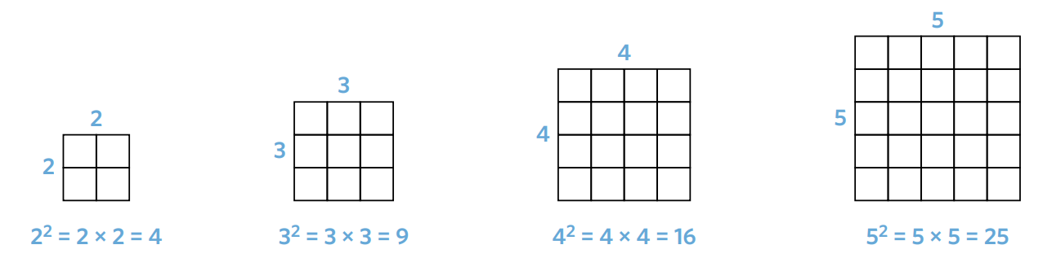
- A perfect square is the square of a whole number.

- Identify Perfect squares
- $1^{2}=1×1=1$ | - $2^{2}=2×2=$ | - $3^{2}=$
- $4^{2}=$ | - $5^{2}=$ | - $6^{2}=$
- $7^{2}=$ | - $8^{2}=$ | - $9^{2}$
- ${10}^{2}=$ | - ${11}^{2}=$ | - ${12}^{2}=$
- ${13}^{2}$ | - ${14}^{2}=$ | - ${15}^{2}=$
Using a calculator, or otherwise, square these numbers.
- ${100}^{2}$ | - ${0.4}^{2}$ | - ${1.1}^{2}$

- Square Roots
- Square rooting a number is the inverse operation of squaring a number.
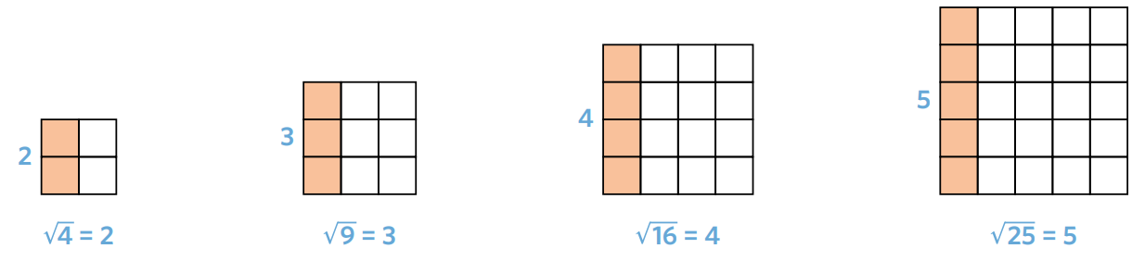

- Identify Square roots
- $\sqrt{1}$ | - $\sqrt{4}$ | - $\sqrt{25}$
- $\sqrt{121}$ | - $\sqrt{16}=$ | - $\sqrt{49}=$
- $\sqrt{36}=$ | - $\sqrt{100}=$ | - $\sqrt{9}=$
- $\sqrt{81}=$ | - $\sqrt{64}=$ | - $\sqrt{144}=$
Using a calculator, or otherwise, square root these numbers.
- $\sqrt{381}$ | - $\sqrt{400}$ | - $\sqrt{2.25}$

- Key Ideas
- Squaring a number means to ……………… a number by itself.
- Square rooting is the ………………… operation of squaring. It will “undo” a square.

Foundation
- Evaluate:
- $6^{2}$  36 | - $6$ squared  36 | - $6$ to the power of 2  36
- $6×6$  36 | - $5^{2}$  25 | - ${11}^{2}$  121
- ${13}^{2}$  169 | - ${12}^{2}$  144 | - $9^{2}$  81
- ${100}^{2}$  10 000 | - $0^{2}$  0 | - $1^{2}$  1

- Evaluate:
- $\sqrt{36}$  6 | - Square root of 36  6 | - $\sqrt{25}$  5
- $\sqrt{169}$  13 | - $\sqrt{4}$  2 | - $\sqrt{0}$  0
- $\sqrt{49}$  7 | - $\sqrt{100}$  10 | - $\sqrt{400}$  20
- $\sqrt{1}$  1 | - $\sqrt{49}$  7 | - $\sqrt{144}$  12
- $\sqrt{169}$  13 | - $\sqrt{196}$  14 | - $\sqrt{225}$  15

- Calculate the area of each square.
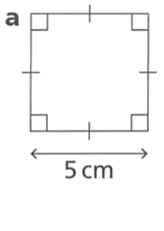  25 cm² | 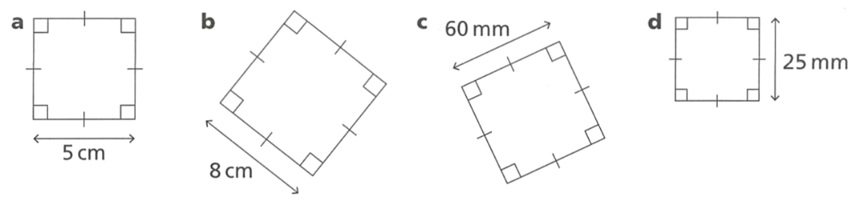  64 cm² | 3600 mm² | 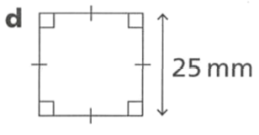  625 mm²

- Find the side lengths of these squares.
7 cm | 8 cm | 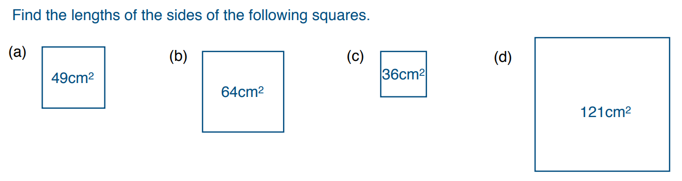  6 cm | 11 cm

- Find the missing values.
3 | 5 | 4 | 7

- List all the square numbers between 101 and 200. Hint: There are only four.

121, 144, 169, 196
- Type $\sqrt{-1}$ into the calculator. Try this with square roots of other negative numbers. Explain.

You cannot square root a negative number, since the square of a number must be positive.
- Fill in the missing numbers to make each box equal to each other.
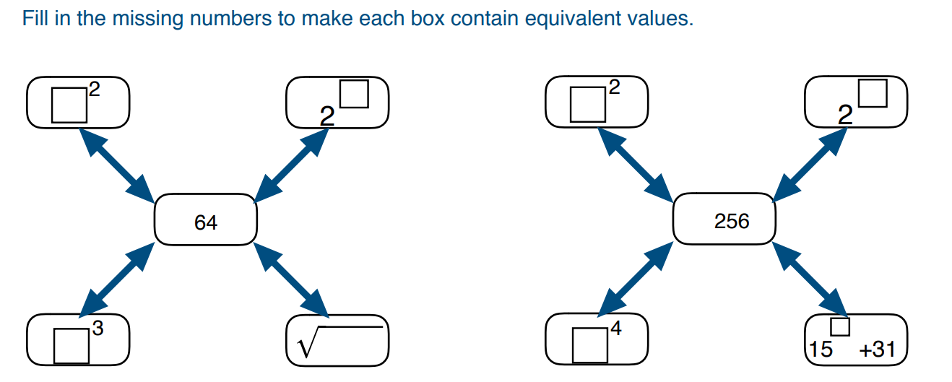  Clockwise from top-left: $8^{2}, 2^{6}, \sqrt{4096,} 4^{3}$ | Clockwise from top-left: ${16}^{2}, 2^{8}, {15}^{2}+31, 4^{4}$

Development
- First determine the prime factorisation of the quantity, then use it to find the square root.
- $196=2×2×7×7$  $=2^{2}×7^{2}$  $={14}^{2}$  $\sqrt{196}=$ ………  14 | - $100=2×2×5×5$  $=$ ……………  $=$ ……………  $\sqrt{100}=$ ……………  10
- $225=3×3×$ ……… $×$ ………  $=3^{2}×$ ……  $=$ …………  $\sqrt{225}=$ …………  15 | - $900=$  $\sqrt{900}=$  30

- Find the square root of each of the following numbers using its prime factorisation.
21 | 75
99 | 36

- Draw the factor tree of $784$  Use the prime factorisation of $784$ to find $\sqrt{784}$  28 | - Draw the factor tree of $4356$  Hence find $\sqrt{4356}$  66

  - List the factors of the number 20
$$1, 20 2, 10 4, 5$$
  - List the factors of the number 49
$$1, 7, 49$$
  - The number of factors of a square number will always be odd. Why is this true?
Factors usually come in “pairs,” so most numbers have an even number of factors.
Square numbers have a “pair” that is a number and itself, so it only counts as 1. An even number of factors plus 1 is always odd.

Mastery

  - Evaluate ${12}^{2}$
144
  - Evaluate $3^{2}×4^{2}$
144
  - The rule ${\left(ab\right)}^{2}=a^{2}b^{2}$ can be used to link ${12}^{2}$ and $3^{2}×4^{2}$. Check this rule is always true using three pairs of other numbers (you may use a calculator).

- Use the rule above to evaluate mentally:
- $2^{2}×4^{2}$  64 | - $6^{2}×2^{2}$  144 | - ${10}^{2}×5^{2}$  2500

- Use a calculator to:
  - Evaluate $\sqrt{36}+\sqrt{64}$
14
  - Evaluate $\sqrt{36+64}$
10
  - Is $\sqrt{36}+\sqrt{64}=\sqrt{36+64}$?
no

- Use a calculator to:
  - Evaluate $\sqrt{36}×\sqrt{64}$
48
  - Evaluate $\sqrt{36×64}$
48
  - Is $\sqrt{36}×\sqrt{64}=\sqrt{36×64}$?
yes

Cube Roots

- Cubing a Number
- Cubing a number means to use a number in a multiplication 3 times.
It is shown by the index number ³
- By cubing a number, we have made a cube with that side length.
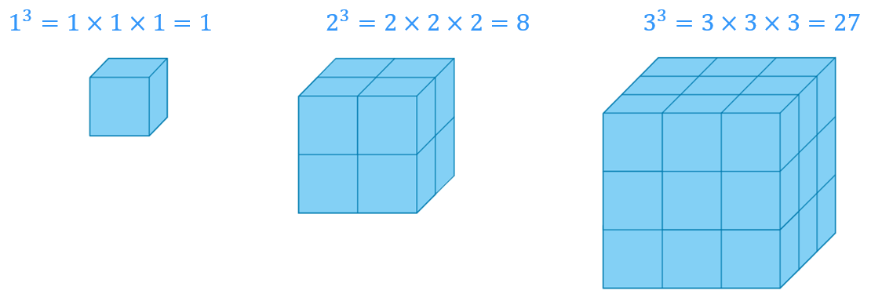

- Cube Rooting
- Cube rooting a number is the inverse operation of cubing a number.
- The cube root symbol is written as $\sqrt[3]{}$

- Identify Perfect cubes and cube roots
- $1^{3}=$ | - $4^{3}=$ | - $\sqrt[3]{1}=$ | - $\sqrt[3]{216}=$
- $2^{3}=$ | - $5^{3}=$ | - $\sqrt[3]{27}=$ | - $\sqrt[3]{64}=$
- $3^{3}=$ | - $6^{3}=$ | - $\sqrt[3]{8}=$ | - $\sqrt[3]{125}=$

- Key Ideas
- Cubing a number means to use a number in a multiplication ……… times.
- Cube rooting is the ………………… operation of cubing. It will “undo” a cube.

Foundation
- Evaluate the following.
- $2^{3}$  8 | - $2$ cubed  8 | - $2$ to the power of 3  8
- $4^{3}$  64 | - $3^{3}$  27 | - $5^{3}$  125
- ${10}^{3}$  1000 | - $\sqrt[3]{64}$  4 | - $\sqrt[3]{125}$  5
- $\sqrt[3]{1000}$  10 | - $\sqrt[3]{1}$  1 | - $\sqrt[3]{0}$  0

- How many small cubes are used to make each bigger cube?
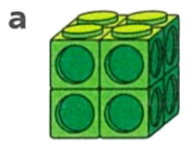  8 | 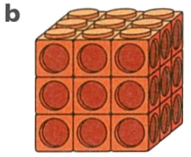  27 | 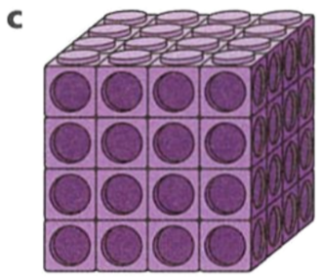  64

- Evaluate each expression.
- $2^{4}$ …………  16  - $8^{2}$ …………  64  - $\sqrt[3]{27}$ …………  3  - $3^{4}$ …………  81  - $\sqrt[3]{1000}$ …………  10 | - $4^{3}$ …………  64  - $3^{4}$ …………  81  - $\sqrt{9}$ …………  3  - $2^{6}$ …………  64  - $\sqrt{256}$ …………  16

Therefore, match the left and right columns in the table above.

Development
- Using a calculator, or otherwise, evaluate the following:
- $\sqrt[3]{27}$  3 | - $\sqrt[4]{16}$  2 | - $\sqrt[5]{100 000}$  10 | - $\sqrt[3]{125}$  5 | - $\sqrt[3]{343}$  7

  - Use the fact that $5^{7}=78 125$ to work out $\sqrt[7]{78 125}$
5
  - Use the fact that $\sqrt[4]{1296}=6$ to evaluate $6^{4}$
1296
  - Given that $2^{10}=1024$, work out ${\left(\sqrt[10]{1024}\right)}^{2}$
4

  - Evaluate $3^{3}$
27
  - Evaluate ${\left(-3\right)}^{3}$
$$-27$$
  - Complete the sentence:
A positive number cubed will always be …………………
positive
A negative number cubed will always be …………………
negative

- $x^{3}=71.$ What is ${\left(-x\right)}^{3}$? Explain how you know.

$-71$, as ${\left(-x\right)}^{3}=-x^{3}$
- $\sqrt[3]{p}=43$. What is $\sqrt[3]{-p}$?

$$-43$$

Estimating Square Roots and Cube Roots

- Estimating Square Roots
$\sqrt{10}$ is the side length of a square with area 10.
10 lies between perfect squares $9$ and $16$, so $\sqrt{10}$ must be between 3 and 4.
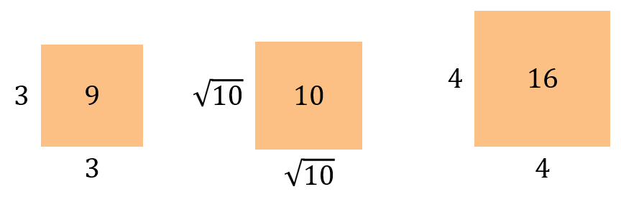

If $a^{2}<x<b^{2}$, then $a<\sqrt{x}<b$

- To estimate square roots:
- Identify two perfect squares between which the given number lies.
- The square root of the number lies between the square roots of these perfect squares.
To get the exact value, you’ll usually need to use a calculator.

- Example Estimate square roots
Estimate the value of $\sqrt{10}$
1. $\sqrt{10}$ is between $\sqrt{9}$ and $\sqrt{16}$
2. $\sqrt{10}$ is between $3$ and $4,$ and closer to 3.
Check using a calculator: $\sqrt{10}=3.16227766…$

- Guided Practice
Estimate the value of these square roots.
- $\sqrt{13}$  $\sqrt{13}$ is between $\sqrt{9}$ and $\sqrt{16}$  $\sqrt{13}$ is between …. and …… | - $\sqrt{17}$  $\sqrt{17}$ is between and  $\sqrt{17}$ is between …… and ……
- $\sqrt{68}$ | - $\sqrt{110}$

Foundation
- Complete the number line.
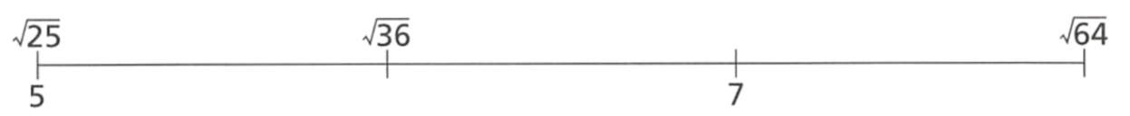
$\sqrt{49}$

6 $8$
Using the number line, between which two integers does each value lie?
7 and 8 | 5 and 6 | 6 and 7 | 7 and 8

- Estimate the value of these square roots and plot their approximate location on a number line. $\sqrt{3}$ has been done for you.
- $\sqrt{1}$  $$\sqrt{1}=1$$ | - $\sqrt{2}$  $$1<\sqrt{2}<2$$ | - $\sqrt{3}$  $$\sqrt{1}<\sqrt{3}<\sqrt{4}$$  $$1<\sqrt{3}<2$$ | - $\sqrt{7}$  $$2<\sqrt{7}<3$$
- $\sqrt{16}$  $$\sqrt{16}=4$$ | - $\sqrt{35}$  $$6<\sqrt{35}<7$$ | - $\sqrt{50}$  $$7<\sqrt{50}<8$$ | - $\sqrt{64}$  $$\sqrt{64}=8$$
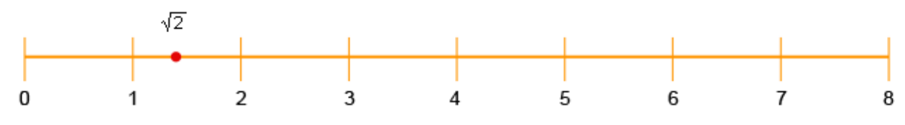

Did you place $\sqrt{3}$ before or after $\sqrt{2}$? Why?

After, since $\sqrt{3}$ must be larger than $\sqrt{2}$
Check the location of your estimates using a calculator.

- Estimate the value of these cube roots and plot their approximate location on a number line.
- $\sqrt[3]{8}$  $$\sqrt[3]{8}=2$$ | - $\sqrt[3]{16}$  $$\sqrt[3]{8}<\sqrt[3]{16}<\sqrt[3]{27}$$ | - $\sqrt[3]{80}$  $$4<\sqrt[3]{80}<5$$ | - $\sqrt[3]{310}$  $$6<\sqrt[3]{310}<7$$
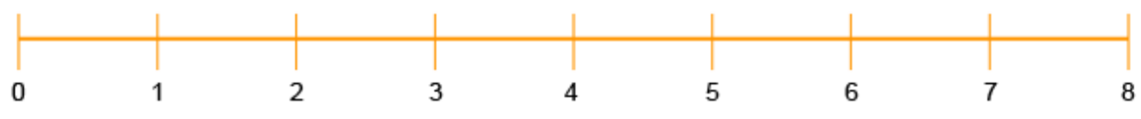

Evaluate Expressions with Roots

- Order of Operations with Roots

Note: There are invisible brackets inside square roots. $\sqrt{a+b}=\sqrt{(a+b)}$

- Example Evaluate expressions with roots
$3^{3}-\sqrt{9}$  $=27-3$  $=24$ | $\sqrt{ 8^{2}+6^{2} }$  $=\sqrt{64+36}$  $=\sqrt{100}$  $=10$

- Guided Practice
Evaluate these expressions
- $\sqrt{81}-3$ | - $\sqrt{121}-2^{4}$
- $\sqrt{3^{2}+4^{2}}$ | - $3^{2}-\sqrt{9}$
- $\sqrt[3]{10^{2}+5^{2}}$ | - $\sqrt{\frac{20×3+15}{3}}$

Foundation
- Evaluate these expressions according to the order of operations.
- $\sqrt{11+5}×2$  8 | - $6×\sqrt{3+1}$  12 | - $45÷\sqrt{17+8}$  9
- $50÷5^{2}+8$  10 | - $100÷{\left(4+1\right)}^{2}$  4 | - $100÷\sqrt{20+5}$  20
- $\sqrt{3^{2}+4^{2}}$  5 | - $\sqrt{5^{2}-3^{2}}$  4 | - $\sqrt{9}×\sqrt{64}÷\sqrt{36}$  2
- $4^{3}+2^{2}$  68 | - $3^{3}+2×4^{2}$  59 | - $5^{2}÷\sqrt{9+16}$  5
- $\frac{5×{\left(3+1\right)}^{2}}{17+3}$  4 | - $\sqrt{\frac{100-64}{9}}$  2 | - $\sqrt{\frac{{10}^{2}-8^{2}}{3^{2}}}$  2
- $\sqrt[3]{\frac{5^{2}-3^{2}}{2}}×\sqrt[3]{8}$  $$4$$ | - $\sqrt{\frac{9-5}{9}}$  $$\frac{2}{3}$$ | - $\sqrt{\frac{28+4}{28+22}}+5$  $$\frac{29}{5}$$

Development
- Evaluate the following.
- $12+4×\sqrt{9}$  24 | - $12×\sqrt{4}-9$  15
- $(12+4)×\sqrt{9}$  48 | - $12×(\sqrt{4}-9)$  $$-84$$
- $12+\sqrt{4×9}$  18 | - $12-9×\sqrt{4}$  $$-6$$
- $\sqrt{12+4}×9$  36 | - ${12}^{2}-9×\sqrt{4}$  126
- $12+\sqrt{4}×\sqrt{9}$  30 | - $({12}^{2}-9)×\sqrt{4}$  270
- $12×\sqrt{4}+9$  33 | - ${12}^{2}-\sqrt{9×4}$  138

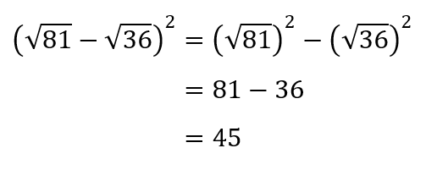
- Explain what is wrong with this solution and provide the correct solution.

Didn’t follow order of operations.
$${\left(9-6\right)}^{2}=3^{2}=9$$
- Evaluate the following:
- $\sqrt{9}+\sqrt{16}×\sqrt{25}$  23 | - $\left(\sqrt{9}+\sqrt{16}\right)×\sqrt{25}$  35
- ${\left(\sqrt{9}+\sqrt{16}\right)}^{2}×\sqrt{25}$  245 | - $2{\left(\sqrt{9}+\sqrt{16}\right)}^{2}×\sqrt{25}$  490

Mastery
- Evaluate the following.
- $\sqrt[3]{59+5}$  4 | - $\sqrt[3]{64×1000}$  40
- $\sqrt[3]{27}+\sqrt[3]{8}$  5 | - $\sqrt[3]{64}-4+\sqrt{81}$  9
- $\sqrt[3]{125}+\sqrt{100}$  15 | - ${\left(\sqrt[3]{216}-\sqrt[3]{64}\right)}^{2}×25$  100
- ${\left(\sqrt[3]{5}\right)}^{3}+\sqrt{25}+11$  21 | - $\frac{\sqrt[3]{64}}{8}$  $$\frac{1}{2}$$

- Show the working out to evaluate the following. Check your answer using a calculator.
- $\left(6×6\right)÷3^{2}-1+{11}^{2}$  124 | - $10+{\left(\left(10-4\right)×\left(2^{3}-6\right)\right)}^{2}÷2+2$  84
- $\sqrt{\left(12×2^{2}-\left(4^{2}-4\right)\right)}×3$  18 | - $\sqrt{\frac{2+4^{2}}{8-2×3}}$  3
- $\sqrt{\left(\left(5^{2}-17\right)+\left(6^{2}-7\right)+2\right)÷3}$  $$\sqrt{13}$$ | - $\sqrt{\frac{{\left(45÷(30-5×3\right))}^{3}×\sqrt{4+5}}{(-{3)}^{2}}}$  3
- Evaluate the following expression.
$$\frac{\sqrt{49}-1}{\sqrt[3]{-64}}×\frac{\sqrt{64}}{\sqrt{25}}÷\frac{{\left(-2\right)}^{2}}{2^{3}}×\frac{\sqrt[3]{125}}{3^{2}}$$

$$-\frac{8}{3}$$
- Evaluate the following.
- ${\left(\frac{1}{5}\right)}^{3}$  $$\frac{1}{125}$$ | - ${\left(\frac{4}{7}\right)}^{2}$  $$\frac{16}{49}$$ | - ${\left(2\frac{1}{4}\right)}^{2}$  $$\frac{81}{16}$$
- $\sqrt{\frac{1}{4}}$  $$\frac{1}{2}$$ | - $\sqrt[3]{-\frac{8}{27}}$  $$-\frac{2}{3}$$ | - $\sqrt{1\frac{24}{25}}$  $$\frac{7}{5}$$
- ${0.5}^{3}$  $$\frac{1}{8}$$ | - $\sqrt{0.04}$  $$0.2$$ | - $\sqrt[3]{0.343}$  $$0.7$$
- ${\left(\frac{1}{2}+\frac{1}{3}\right)}^{2}$  $$\frac{25}{36}$$ | - ${\left(\frac{1}{2}\right)}^{2}+{\left(\frac{1}{3}\right)}^{3}$  $$\frac{31}{108}$$ | - ${\left(\sqrt{49}×\frac{1}{5}\right)}^{3}$  $$\frac{343}{125}$$
- $\sqrt{\frac{2}{5}×1\frac{3}{5}}$  $$\frac{4}{5}$$ | - ${\left(1.8-0.9\right)}^{2}$  $$0.81$$ | - $\sqrt{1.2-1+0.05}$  $$0.5$$
- $\sqrt{6\frac{19}{25}}$  $$\frac{13}{5}$$ | - $\sqrt[3]{1.728}$  $$\frac{6}{5}$$ | - $\sqrt{3\frac{1}{9}×1\frac{1}{6}×\frac{2}{3}}$  $$\frac{14}{9}$$

Index Law of Multiplication

- Investigation Index law of multiplication
$$3^{2}×3^{4}=\left(3×3\right)×\left(3×3×3×3\right)$$ $=$ …………… | $2^{3}×2^{2}=$ (… $×$ … $×$ …) $×$ (… $×$ …)  $=$ ……………
English
expression: When multiplying two numbers with the ……… base, …… the powers.

Algebraic
expression: $a^{m}×a^{n}=a^{m+n}$

- Identify When you can use the index law of multiplication
✖  $$8^{2}+8^{3}$$ | ✔  $$8^{2}×8^{3}$$ | ✔  $${\left(-5\right)}^{-4}×{\left(-5\right)}^{\frac{1}{7}}$$ | ✖  $$5^{4}×3^{7}$$
Identify in which of the following scenarios you can use the index law of multiplication.
- $7^{3}×7^{2}$ | - $7^{3}+7^{2}$ | - $7^{3}+6^{2}$ | - $6^{3}×6^{2}$
- $6^{-3}×6^{-2}$ | - $6^{-3}×6^{2}$ | - ${\left(-3\right)}^{-3}×{\left(-3\right)}^{2}$ | - ${\left(\frac{1}{3}\right)}^{0.5}×{\left(\frac{1}{3}\right)}^{\frac{3}{5}}$

- Index Law of Multiplication
$$a^{m}×a^{n}=a^{m+n}$$

- Simplify expressions using the index law of multiplication
- $7^{3}×7^{5}$ | - ${10}^{3}×{10}^{4}$ | - ${12}^{3}×{12}^{6}$
- $9×9^{2}$ | - $2^{4}×2^{3}×2$ | - $7^{5}×7^{4}×7^{3}$

Foundation
- Write the following in expanded form:
  - $5^{2}=$ …… $×$ ……
$$5×5$$
  - $5^{7}=$ …… $×$ …… $×$ …… $×$ …… $×$ …… $×$ …… $×$ ……
$$5×5×5×5×5×5×5$$
  - $5^{2}×5^{7}=$ …… $×$ …… $×$ …… $×$ …… $×$ …… $×$ …… $×$ …… $×$ …… $×$ ……
$$5×5×5×5×5×5×5×5×5$$
  - Write the answer to part c in index form: ………
$$5^{9}$$
  - Does $5^{2}×5^{7}=5^{2+7}?$ …………………
yes
- Simplify the following.
$$8^{14}$$ | $$7^{9}$$
$$9^{10}$$ | $$5^{17}$$

- Simplify these expressions using the index law of multiplication.
- $3^{5}×3^{4}$  $$3^{9}$$ | - $2^{7}×2^{5}$  $$2^{12}$$ | - $7^{2}×7^{8}$  $$7^{10}$$ | - $6^{9}×6^{4}$  $$6^{13}$$
- $5^{4}×5$  $$5^{5}$$ | - $2^{4}×2^{4}$  $$2^{8}$$ | - $8^{9}×8^{12}$  $$8^{21}$$ | - $2×2^{9}$  $$2^{10}$$
- $2^{4}×2^{6}×2^{3}$  $$2^{13}$$ | - $3^{8}×3^{3}×3^{7}$  $$3^{18}$$ | - $9^{2}×9^{5}×9^{4}$  $$9^{11}$$ | - $4^{6}×4^{3}×4$  $$4^{10}$$

- Simplify these expressions using the index law of multiplication.
- $5^{5}×5^{3}=$  $$5^{8}$$ | - $3^{-3}×3^{-5}=$  $$3^{-8}$$
- $5^{5}×5^{2}=$  $$5^{7}$$ | - $3^{3}×3^{5}=$  $$3^{8}$$
- $5^{2}×5^{5}=$  $$5^{7}$$ | - ${(-3)}^{3}×{(-3)}^{5}=$  $${\left(-3\right)}^{8}$$
- $5^{2}×4^{5}=$  Can’t simplify | - $3^{0.3}×3^{0.5}=$  $$3^{0.8}$$
- $4^{2}×4^{5}=$  $$4^{7}$$ | - $3^{\frac{1}{3}}×3^{\frac{1}{5}}=$  $$3^{\frac{8}{15}}$$
- $4×4^{5}=$  $$4^{6}$$ | - $3^{a}×3^{a}=$  $$3^{2a}$$
- $4^{3}×4^{5}=$  $$4^{8}$$ | - $3^{a}×3^{b}=$  $$3^{a+b}$$
- $4^{3}×4^{-5}=$  $$4^{-2}$$ | - $a^{3}×b^{3}=$  $${\left(ab\right)}^{3}$$
- $4^{-3}×4^{5}=$  $$4^{2}$$ | - $a^{3}×a^{3}=$  $$a^{6}$$
- $4^{-3}×4^{-5}=$  $$4^{-8}$$ | - ${\left(\frac{1}{a}\right)}^{3}×{\left(\frac{1}{a}\right)}^{3}$ $=$  $${\left(\frac{1}{a}\right)}^{6}$$

Index Law of Division

- Investigation Index law of division
$$2^{5}÷2^{3}=\frac{2×2×2×2×2}{2×2×2}$$  $=$ ………… | $$3^{6}÷3^{2}=\frac{3×3×3×3×3×3}{3×3}$$  $=$ …………
English
expression: When dividing two numbers with the ……… base, …… the powers.

Algebraic
expression: …………………………………………………………………………………………

- Identify When you can use the index law of division
✖  $$8^{5}-8^{3}$$ | ✔  $$8^{5}÷8^{3}$$ | ✔  $$\frac{{\left(-5\right)}^{11}}{{\left(-5\right)}^{68}}$$ | ✖  $$\frac{5^{11}}{3^{68}}$$
Identify in which of the following scenarios you can use the index law of multiplication.
- ${11}^{3}÷{11}^{2}$ | - ${11}^{3}-{11}^{2}$ | - ${11}^{3}÷5^{2}$ | - $\frac{{11}^{5}}{{11}^{3}}$
- $\frac{{11}^{5}}{5^{3}}$ | - $5^{-3}÷5^{-2}$ | - ${\left(-5\right)}^{-3}÷{\left(-5\right)}^{2}$ | - ${15}^{0.5}÷5^{2.5}$

- Index Law of Division
$$a^{m}÷a^{n}=a^{m-n}$$

- Simplify expressions using the index law of division
- $7^{8}÷7^{5}$ | - $\frac{9^{5}}{9}$ | - ${13}^{8}÷{13}^{5}$
- $\frac{7^{16}}{7^{12}}$ | - $3^{200}÷3^{180}$ | - $\frac{{89}^{53}}{{89}^{52}}$

Foundation
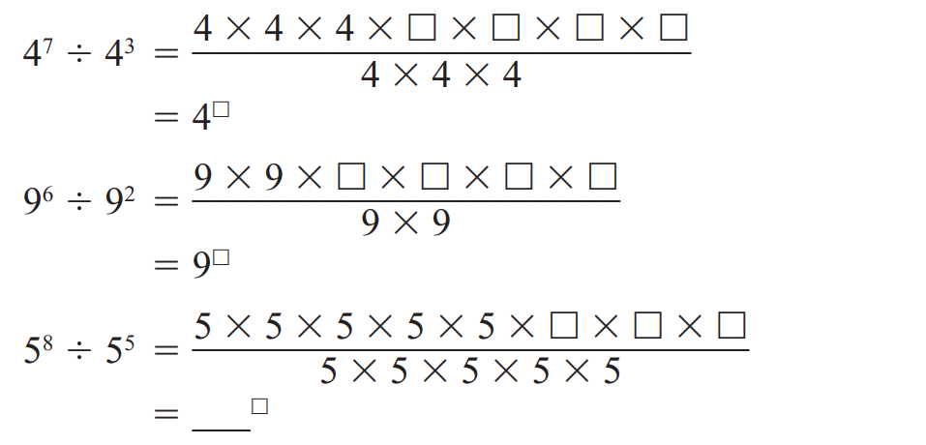
- Simplify each of the following by writing in expanded form.

$$4^{4}$$

$9^{4}$

$5^{3}$
- Simplify the following.
$$3^{5}$$ | $$7^{2}$$ | $$2^{5}$$ | $$9^{1}$$
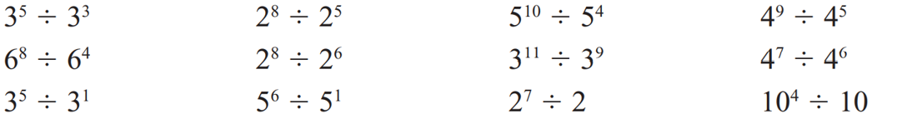  $$3^{2}$$ | $$2^{3}$$ | $$5^{6}$$ | $$4^{4}$$
$$3^{4}$$ | $$5^{5}$$ | $$2^{6}$$ | $${10}^{3}$$

- Simplify the following.
- $6^{6}÷6^{3}=$  $$6^{3}$$ | - $5^{-2}÷5^{-6}=$  $$5^{4}$$ | - $\frac{4^{6}}{4^{6}}$ $=$  $$1$$
- $6^{6}÷6^{2}=$  $$6^{4}$$ | - $5^{-6}÷5^{-2}=$  $$5^{-4}$$ | - $\frac{4^{m}}{4^{m}}$ $=$  $$1$$
- $6^{6}÷5^{2}=$  Can’t simplify | - ${(-5)}^{6}÷{(-5)}^{2}=$  $${\left(-5\right)}^{4}$$ | - $\frac{4^{m}}{4^{p}}$ $=$  $$4^{m-p}$$
- $5^{6}÷5^{2}=$  $$5^{4}$$ | - ${(-4)}^{6}÷{(-5)}^{2}=$  Can’t simplify | - $\frac{m^{4}}{p^{4}}$ $=$  $${\left(\frac{m}{p}\right)}^{4}$$
- $5^{2}÷5^{6}=$  $$5^{-4}$$ | - $\frac{4^{6}}{4^{2}}$ $=$  $$4^{4}$$ | - $\frac{m^{4}}{m^{6}}$ $=$  $$m^{-2}$$
- $5^{-2}÷5^{6}=$  $$5^{-8}$$ | - $\frac{4^{0.6}}{4^{0.2}}$ $=$  $$4^{0.4}$$ | - $\frac{4^{0.6}}{4^{0.2}}$ $=$  $$4^{0.4}$$
- $5^{2}÷5^{-6}=$  $$5^{8}$$ | - $\frac{4^{\frac{1}{2}}}{4^{\frac{1}{6}}}$ $=$  $$4^{\frac{1}{3}}$$ | - $\frac{4^{6}}{4^{6}}$ $=$  $$4^{\frac{1}{3}}$$

Index Law of Power of a Power

- Investigation Index law of power of a power
$${\left(2^{2}\right)}^{3}=\left(2×2\right)×\left(2×2)×(2×2\right)$$ $=$ …………………

${\left(3^{3}\right)}^{4}=$ (………………) $×$ (………………) $×$ (………………) $×$ (………………)
$=$ …………………
$${\left(7^{2}\right)}^{5}=$$ $=$

English
expression: …………………………………………………………………………………
Algebraic
expression: …………………………………………………………………………………

- Index Law of Power of a Power
$${\left(a^{m}\right)}^{n}=a^{m×n}$$

- Simplify expressions using the index law of power of a power
- ${\left(7^{3}\right)}^{5}$ | - ${\left(7^{5}\right)}^{8}$ | - ${\left(4^{5}\right)}^{3}$
- ${\left(4^{7}\right)}^{2}$ | - ${\left(3^{10}\right)}^{10}$ | - ${\left({125}^{3}\right)}^{25}$

Foundation
- Simplify each of the following by writing in expanded form.
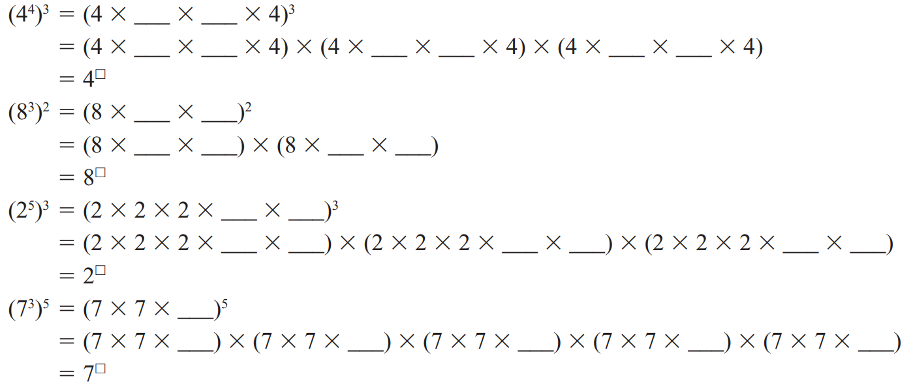

$$4^{12}$$

$$8^{6}$$

$$2^{15}$$

$$7^{15}$$

- Simplify the following.
12 | 6 | 15 | 15

- Simplify these expressions using the index law of power of a power.
- ${\left(6^{2}\right)}^{5}=$  $$6^{10}$$ | - ${\left(3^{2}\right)}^{\frac{1}{2}}=$  $$3$$
- ${\left(6^{3}\right)}^{5}=$  $$6^{15}$$ | - ${\left(3^{\frac{1}{2}}\right)}^{2}=$  $$3$$
- ${\left(6^{4}\right)}^{5}=$  $$6^{20}$$ | - ${\left(3^{\frac{1}{2}}\right)}^{\frac{1}{2}}=$  $$3^{\frac{1}{4}}$$
- ${\left(2^{4}\right)}^{5}=$  $$2^{20}$$ | - ${\left(x^{2}\right)}^{2}=$  $$x^{4}$$
- ${\left(2^{5}\right)}^{4}=$  $$2^{20}$$ | - ${\left(x^{2}\right)}^{7}=$  $$x^{14}$$
- ${\left(2^{5}\right)}^{1}=$  $$2^{5}$$ | - ${\left(2^{7}\right)}^{x}=$  $$2^{7x}$$
- ${\left(2^{5}\right)}^{-1}=$  $$2^{-5}$$ | - ${\left(7^{x}\right)}^{2}=$  $$7^{2x}$$
- ${\left(2^{-5}\right)}^{-1}=$  $$2^{5}$$ | - ${\left(x^{2}\right)}^{5}=$  $$x^{10}$$
- ${\left(3^{-5}\right)}^{-1}=$  $$3^{5}$$ | - ${\left(x^{2}\right)}^{a}=$  $$x^{2a}$$

  - By evaluating both sides of the equation, show that $6^{2}=2^{2}×3^{2}$.

$$36=4×9$$
  - Therefore, write $6^{3}$ as a product of powers of 2 and 3.

$$6^{3}=2^{3}×3^{3}$$
  - Write ${10}^{2}$ as a product of powers of 2 and 5.

$$2^{2}×5^{2}$$

- In general, ${\left(ab\right)}^{2}=a^{2}×b^{2}$.
Use this rule to find the prime factorisation of these numbers.
- $6^{4}$  $$2^{4}×3^{4}$$ | - ${10}^{3}$  $$2^{3}×5^{3}$$ | - ${14}^{2}$  $$2^{2}×7^{2}$$
- ${22}^{3}$  $$2^{3}×{11}^{3}$$ | - ${20}^{3}$  $$2^{6}×5^{3}$$ | - ${12}^{4}$  $$2^{8}×3^{4}$$

Index Law of Zero Power

- Investigation Index law of zero power
$2^{3}=$  $2^{2}=$  $2^{1}=$  $2^{0}=$ | $3^{3}=$  $3^{2}=$  $3^{1}=$  $3^{0}=$ | ${(-2)}^{3}=$  ${(-2)}^{2}=$  ${(-2)}^{1}=$  ${(-2)}^{0}=$
English
expression: …………………………………………………………………………………
Algebraic
expression: …………………………………………………………………………………

The index law of division can be used to show any base raised to the power of 0 is 1:
- $9^{2}÷9^{2}$ | - $\frac{9^{3}}{9^{3}}$ | - $\frac{(-{5)}^{2}}{(-{5)}^{2}}$

- Index Law of Zero Power
$$a^{0}=1$$

- Simplify expressions using the index law of power of a power
- ${14}^{0}$ | - $4^{0}$ | - ${\left({91}^{23}\right)}^{0}$
- ${\left({11}^{0}\right)}^{500}$ | - $72+{72}^{0}$ | - ${\left(-3\right)}^{0}$
- $-3^{0}$ | - $6×6^{0}$ | - $8×9^{0}$

Foundation
- Simplify these expressions using the power of zero.
- $2^{0}=$  1 | - $6^{0}=$  1
- $3^{0}=$  1 | - ${\left(-6\right)}^{0}=$  1
- $4^{0}=$  1 | - ${-(6)}^{0}=$  $$-1$$
- $5^{0}=$  1 | - ${\left(\frac{1}{6}\right)}^{0}=$  1
- $0^{5}=$  0 | - ${\left(0.6\right)}^{0}=$  1
- $0^{4}=$  0 | - ${\left(6p\right)}^{0}=$  1
- $0^{0}=$  Undefined :0 | - ${6p}^{0}=$  6

- Simplify these expressions.
- $5^{0}×{13}^{0}$  1 | - $4^{0}+7^{0}$  2 | - ${11}^{0}-6^{0}$  0 | - $18×7^{0}$  18

  - Use the index law for division to write $\frac{5^{2}}{5^{2}}$ as a power of 5.
$$5^{2-2}=5^{0}$$
  - If a number is divided by itself, what is the answer?
1, so $5^{0}=1$

- Simplify these expressions.
- ${\left(-5\right)}^{0}$  1 | - $-5^{0}$  $$-1$$ | - $6^{0}-5^{0}$  0 | - $6^{0}-{(-5)}^{0}$  0
- $6^{0}+{\left(-5\right)}^{0}$  2 | - ${\left(-6\right)}^{0}+{\left(-5\right)}^{0}$  2 | - $-6^{0}+{\left(-5\right)}^{0}$  0 | - $-6^{0}-5^{0}$  $$-2$$

Mixed Practice

- Index Laws
Multiplication  $$a^{m}×a^{n}=a^{m+n}$$ | Division  $$\frac{a^{m}}{a^{n}}=a^{m-n}$$
Power of a Power  $${\left(a^{m}\right)}^{n}=a^{m×n}$$ | Zero  $$a^{0}=1$$

- Review
- Identify whether an index law can be used to simplify an expression
- $x^{2}×x^{3}=x^{6}$  - $x^{4}×x^{5}=x^{20}$  - $x^{3}×x^{6}=x^{9}$  - $x×x^{7}=x^{7}$  - $x^{5}×x=x^{6}$ | True | False  True | False  True | False  True | False  True | False | - $x^{8}÷x^{2}=x^{4}$  - $x^{6}÷x^{3}=x^{3}$  - $x^{27}÷x^{3}=x^{24}$  - $x^{5}÷x^{5}=x$  - $x^{4}÷x^{4}=x^{0}=1$ | True | False  True | False  True | False  True | False  True | False

- Simplify expressions using index laws
- $3^{5}×3^{7}$ | - $5^{0}$ | - ${\left(-6\right)}^{0}$
- $7^{4}÷7^{2}$ | - $8^{9}×8$ | - $2^{4}×2^{3}$
- $-(4^{0})$ | - $4^{0}$ | - $-4^{0}$
- ${\left(4^{3}\right)}^{5}$ | - ${\left(7^{5}\right)}^{2}$ | - ${\left(3^{2}\right)}^{3}$
- ${12}^{5}÷{12}^{3}$ | - $3^{5}×2^{3}$ | - $7^{11}÷7^{9}$

Foundation
- Simplify these expressions.
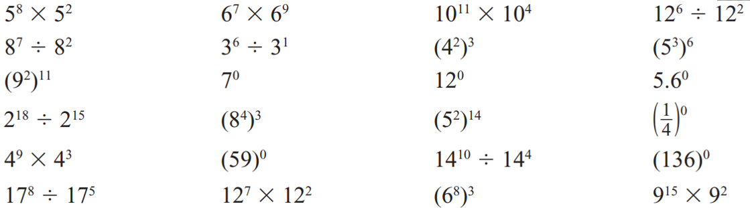  $$5^{10}$$ | $$6^{16}$$ | $${10}^{15}$$ | $${12}^{4}$$
$$8^{5}$$ | $$3^{5}$$ | $$4^{6}$$ | $$5^{18}$$
$$9^{22}$$ | 1 | 1 | 1
$$2^{3}$$ | $$8^{12}$$ | $$5^{28}$$ | 1
$$4^{12}$$ | 1 | $${14}^{6}$$ | 1
$${17}^{3}$$ | $${12}^{9}$$ | $$6^{24}$$ | $$9^{17}$$

- Determine whether you can use the index law of division to simplify these expressions.
If so, write the simplified form.
- $9^{5}÷9^{3}$  $$9^{2}$$ | - $9^{4}÷4^{5}$  no | - $6^{4}÷6$  $$6^{3}$$ | - ${10}^{3}÷{10}^{-1}$  $${10}^{4}$$
- $8^{2}÷8^{2}$  1 | - $5^{4}-5^{3}$  no | - $6^{-3}÷6^{2}$  $$6^{-5}$$ | - $4^{1.5}÷4^{0.5}$  $$4$$

- Determine whether you can use the index law of multiplication to simplify these expressions.
If so, write the simplified form.
- $5^{4}×5^{3}$  $$5^{7}$$ | - $5^{4}+5^{3}$  no | - $5^{4}×6^{3}$  no | - $2^{7}×2^{-2}$  yes
- $3^{5}×3$  $$3^{6}$$ | - $8^{2}+8^{4}$  no | - $6^{-3}×6^{2}$  $$6^{-5}$$ | - $4^{1.5}×4^{0.5}$  $$4^{2}$$

- Write true or false for these statements.
- ${\left(5^{2}\right)}^{12}=5^{24}$  T | - ${\left(3^{6}\right)}^{2}=3^{8}$  F | - $1^{0}=1$  T
- ${\left(3^{2}\right)}^{10}=9^{20}$  F | - $3{\left(4\right)}^{0}=1$  F | - $0^{3}=0$  T

Development
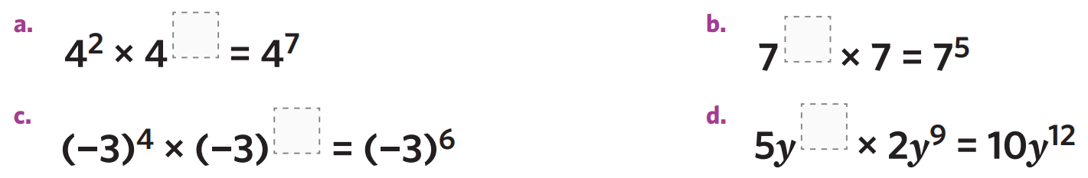
- Fill in the missing indices so each of these expressions is true.
5 | 4 | 2
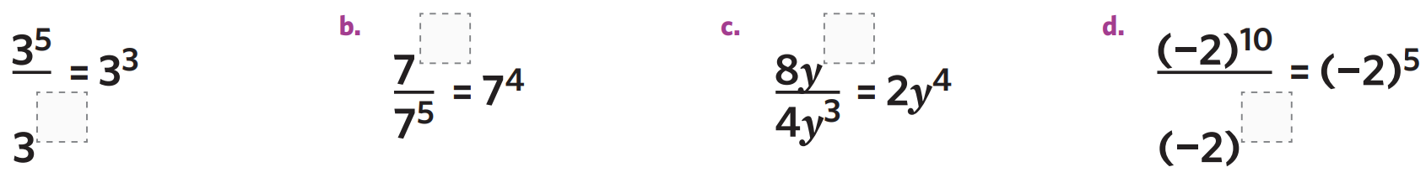  9 | 2 | 5

- Complete these equations:
- $5^{2}×$ ……… $=5^{6}$  $$5^{4}$$ | - ……… $÷3^{4}=3^{3}$  $$3^{7}$$ | - $2^{7}÷$ ……… $=2^{-1}$  $$2^{8}$$

- Find the missing value to make the equation true.
5 | 3
5 | 2

- Determine whether these equations are true or false.
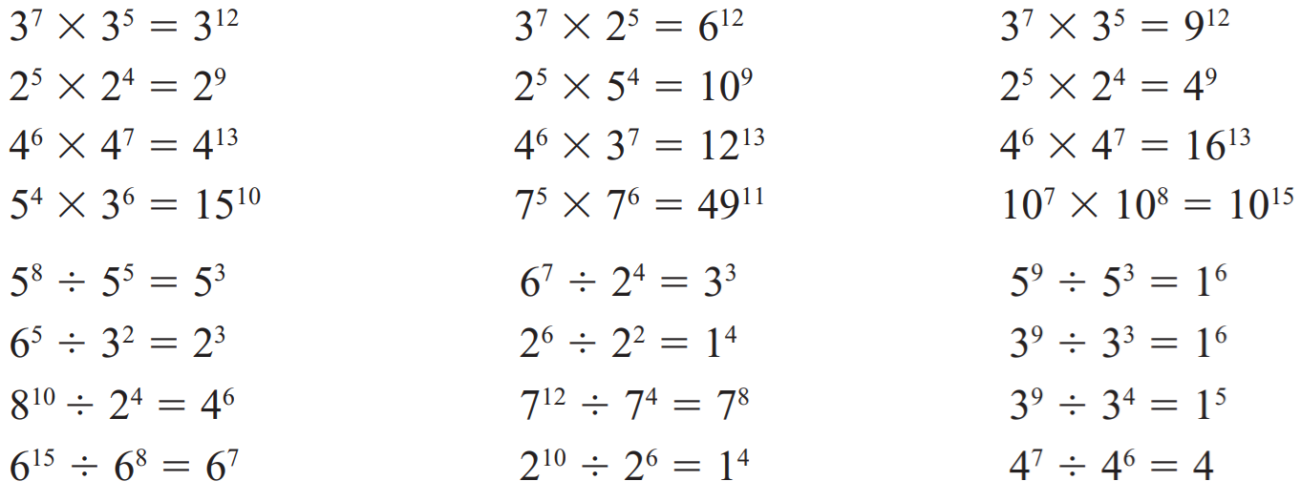  T | F | F
T | F | F
T | F | F
F | F | F
T | F | F
F | T | F
T | F | T
F | F | T

- Simplify the following using index laws.
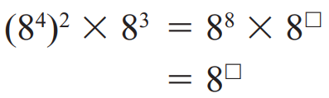  $$8^{11}$$ | 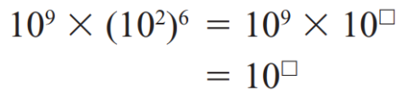  $$1)^21$$ | 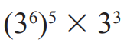  $$3^{33}$$
$$7^{14}$$ | 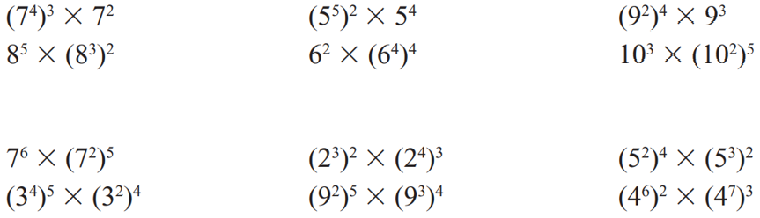  $$5^{14}$$ | $$9^{11}$$
$$8^{11}$$ | $$6^{18}$$ | $${10}^{13}$$
$$7^{16}$$ | $$2^{18}$$ | $$5^{14}$$
$$3^{28}$$ | $$9^{22}$$ | $$4^{33}$$

- Simplify the following using index laws.
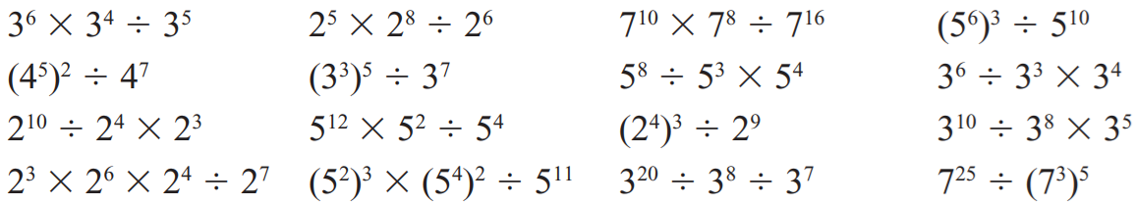  $$3^{5}$$ | $$2^{7}$$ | $$7^{2}$$ | $$5^{8}$$
$$4^{3}$$ | $$3^{8}$$ | $$5^{9}$$ | $$3^{7}$$
$$2^{9}$$ | $$5^{10}$$ | $$2^{3}$$ | $$3^{7}$$
$$2^{3}$$ | $$5^{3}$$ | $$3^{5}$$ | $$7^{10}$$

- Simplify each of the following by combining index laws.
- $4×{(4^{3})}^{2}$  $$4^{7}$$ | - ${\left(3^{4}\right)}^{2}×3$  $$3^{9}$$ | - $7^{8}÷{\left(7^{3}\right)}^{2}$  $$7^{2}$$
- ${\left(4^{2}\right)}^{3}÷4^{5}$  $$4$$ | - ${\left(3^{6}\right)}^{3}÷{\left(3^{5}\right)}^{2}$  $$3^{8}$$ | - ${2^{2}×(2^{2})}^{8}÷{\left(2^{3}\right)}^{3}$  $$2^{9}$$

- Simplify these expressions.
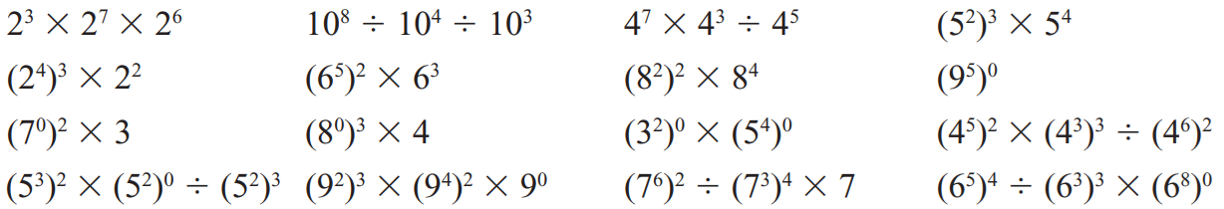  $$2^{14}$$ | $$6^{13}$$ | $$8^{8}$$ | 1
3 | 4 | 1 | $$4^{7}$$
1 | $$9^{14}$$ | 7 | $$6^{11}$$

Mastery
- Fill in the empty boxes to make the expressions equal.
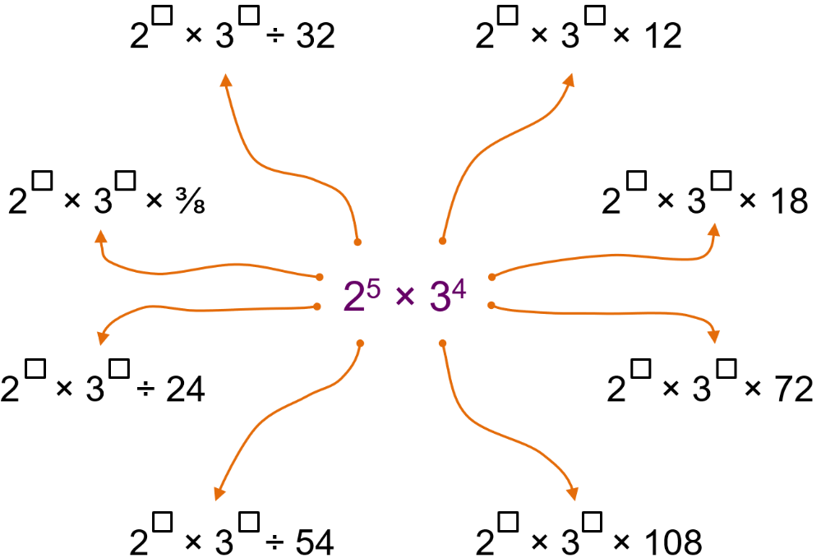

Clockwise from top left
$$2^{10}×3^{4}÷32$$
$$2^{3}×3^{3}×12$$
$$2^{4}×3^{2}×18$$
$$2^{2}×3^{2}×72$$
$$2^{3}×3^{1}×108$$
$$2^{6}×3^{7}÷54$$
$$2^{8}×3^{5}÷24$$
$$2^{8}×3^{3}×3/8$$
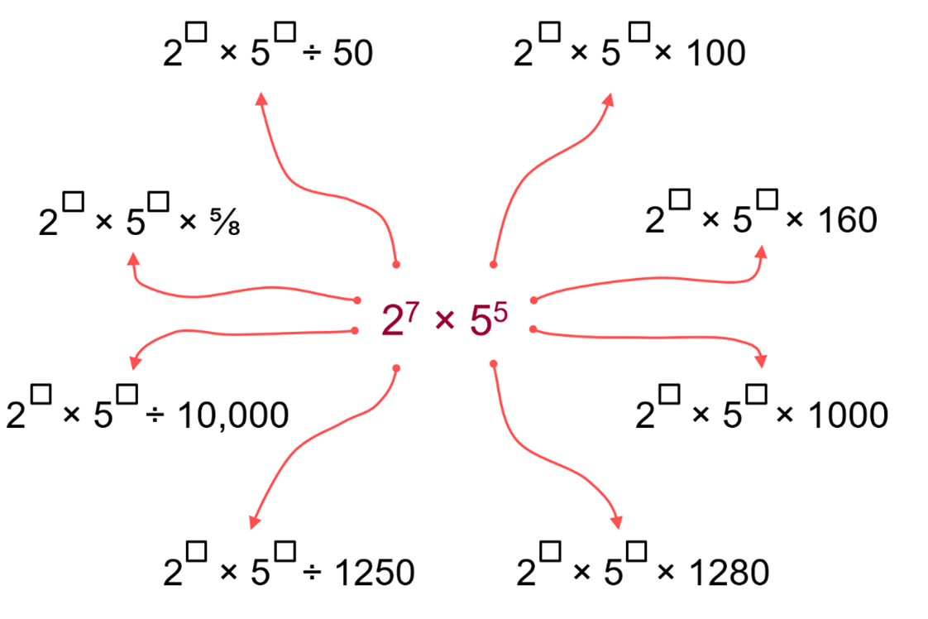

Clockwise from top left
$$2^{8}×5^{7}÷50$$
$2^{5}×5^{3}×100$
$$2^{2}×5^{4}×160$$
$$2^{4}×5^{2}×1000$$
$$2^{-1}×5^{4}×1280$$
$$2^{8}×5^{9}÷1250$$
$$2^{11}×5^{9}÷10000$$
$$2^{10}×5^{4}×5/8$$

- Given that $2^{12}=4096$ and $2^{8}=256$, find the number that makes this equation true:
$$256× ?=4096$$

$2^{4}$, or 16
- If $\frac{2^{a}}{2^{b}}$ $=8$, then what is $\frac{5^{a}}{5^{b}}$?
$$2^{a-b}=2^{3}$$
$$a-b=3,$$
$$so 5^{a-b}=5^{3}=125$$

  - Use the fact that ${\left(2^{2}\right)}^{3}=2^{6}$ to simplify ${\left({\left(2^{2}\right)}^{3}\right)}^{4}$
$$2^{24}$$
  - Simplify ${\left({\left(2^{3}\right)}^{4}\right)}^{5}$
$$2^{60}$$
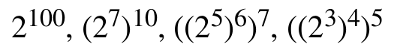
  - Arrange these numbers in ascending order.

$${\left({\left(2^{3}\right)}^{4}\right)}^{5}, {\left(2^{7}\right)}^{10}, 2^{100},{\left({\left(2^{5}\right)}^{6}\right)}^{7}$$
- Find the prime factorisation of the following without a factor tree by using index laws.
- $100$  $$={10}^{2}$$  $$={\left(2×5\right)}^{2}$$  $=2×5×2×5$  $=2^{2}×5^{2}$ | - $1000$  $$2^{3}×5^{3}$$ | - ${25}^{7}$  $$5^{14}$$ | - ${18}^{30}$  $$2^{30}×3^{60}$$
- $4^{6}×8^{6}$  $$2^{30}$$ | - $9^{3}×18$  $$2×3^{8}$$ | - $12×2^{100}$  $$2^{102}×3$$ | - ${1 000 000}^{100}$  $$2^{600}×5^{600}$$
- Which two whole numbers, neither ending in zero, equal 1 000 000 000 when multiplied?
(hint: start by looking for numbers that multiply to 10, 100, 1000, etc.)

$$2^{9}×5^{9}$$

Evaluating Expressions by Applying Index Laws

- Example Evaluate expressions using index laws
Evaluate:
$4+4^{5}÷4^{3}$  $=$ $4+4^{2}$  $=4+16$  $=20$ | $\frac{4^{5}×4^{3}}{4^{7}}$  $=$ $\frac{4^{8}}{4^{7}}$  $=4^{1}$  $=4$

- Guided Practice
Evaluate:
- $5^{2}×(2^{6}÷2^{3})$  200 | - $\frac{5^{7}×5^{4}}{5^{11}}$  1
- ${\left(4^{0}×3^{4}÷3^{3}\right)}^{2}$  9 | - ${\left(2^{5}÷2^{4}×3\right)}^{2}$  36

Foundation
- Evaluate the following expressions, give your answer as a basic numeral.
- $7^{7}÷7^{5}$  49 | - ${10}^{6}÷{10}^{5}$  10 | - ${101}^{5}÷{101}^{4}$  101
- $2^{3}×2^{2}$  32 | - $3^{2}×3$  27 | - $4^{4}÷4^{4}$  1
- ${200}^{30}÷{200}^{28}$  40000 | - $7×({31}^{16}÷{31}^{15})$  217 | - $3×({50}^{200}÷{50}^{198})$  7500

- Evaluate these using your knowledge of the zero index.
- $4^{0}$  1 | - $5^{2}÷4^{0}$  25 | - ${10}^{3}÷{15}^{0}$  1000 | - $4^{6}×4^{0}$  4096
- ${\left(5^{6}\right)}^{0}$  1 | - ${\left(2^{4}\right)}^{0}$  1 | - ${\left(3^{6}\right)}^{0}$  1 | - ${\left(3^{0}\right)}^{6}$  1
- ${-\left(x^{0}\right)}^{6}$  $$-1$$ | - ${\left(a^{0}\right)}^{3}$  1 | - ${\left(q^{5}\right)}^{0}$  1 | - ${\left(5^{6}\right)}^{0}$  1

- Evaluate these. An example is provided.
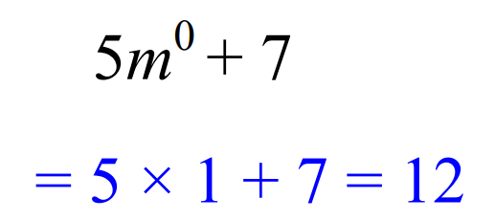

- $2v^{0}$  $$=2×1=$$  2 | - $8h^{0}$  8 | - $h^{0}+7$  8 | - $7h^{0}-4$  3
- $x^{0}$  1 | - $2x^{0}$  2 | - $2x^{0}+2$  4 | - $x^{0}+2x^{0}$  3
- $n^{0}$  1 | - $4^{0}$  1 | - $4n^{0}$  4 | - ${\left(4n\right)}^{0}$  1
- $4n^{0}+4$  8 | - ${\left(n^{0}+4\right)}^{2}$  25 | - $4n^{0}+{\left(4n\right)}^{0}$  5 | - $4^{0}n$  $$n$$

Development
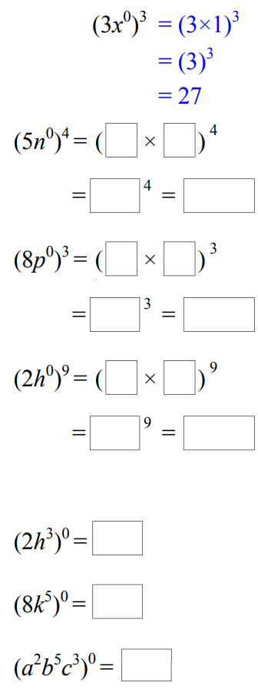
- Study the example and simplify these.

625 | 512 | 512
- ${\left(2h^{0}\right)}^{3}$  8 | - ${\left(8k^{0}\right)}^{2}$  64 | - ${\left(3x^{0}y^{0}\right)}^{4}$  81
- ${\left(2h^{3}\right)}^{0}$  1 | - ${\left(8k^{2}\right)}^{0}$  1 | - ${\left(3x^{2}y^{4}\right)}^{0}$  1

- Evaluate each of the following by combining index laws.
- ${\left(2^{4}\right)}^{8}÷2^{30}$  4 | - ${\left({10}^{3}\right)}^{7}÷{10}^{18}$  1000 | - ${\left({\left(-1\right)}^{11}\right)}^{2}×{\left({\left(-1\right)}^{2}\right)}^{11}$  1

  - According to the index laws, what would ${\left(9^{0.5}\right)}^{2}$be?
9
  - Using what you got above, what is $9^{0.5}?$
3
  - What would ${16}^{0.5}$be?
4
  - What would ${25}^{0.5}$be?
5
  - What would ${36}^{0.5}$be?
6
  - What would $x^{0.5}$be?
$$\sqrt{x}$$

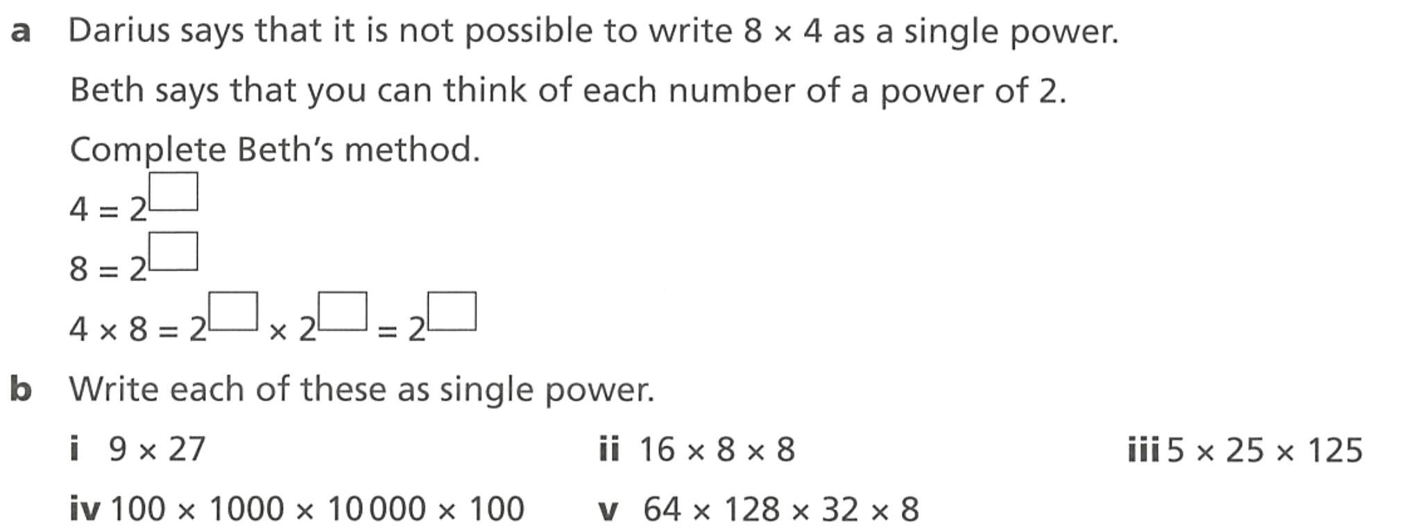
Mastery

2
3
2, 3, 5

$$3^{5}$$ | $$2^{10}$$ | $$5^{6}$$
$${10}^{11}$$ | $$2^{21}$$
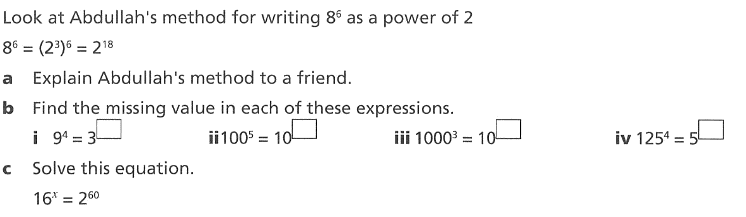

  - Explain Abdullah’s method.

He changed 8 to $2^{3}$, then used index law of power of a power.
8 | 10 | 9 | 12

$$2^{4x}=2^{60}$$
$$x=15$$
- Fill in the blanks.
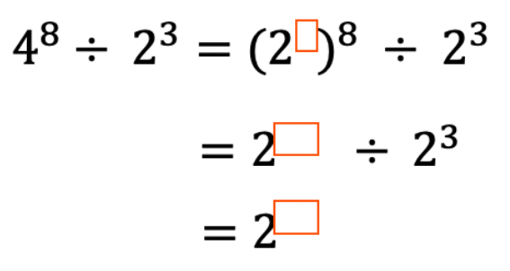  $$2^{13}$$ | 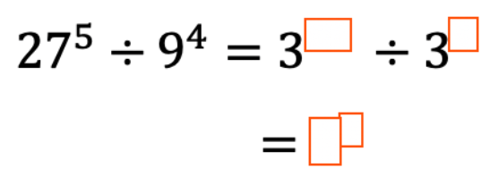  $$3^{7}$$

- Given that $4=2^{2},$ simplify these expressions to a single smallest base number.
- $4×2$  $$2^{3}$$ | - $8×4^{2}×2^{3}$  $$2^{10}$$ | - $3×9×{27}^{2}$  $$3^{9}$$
- ${25}^{5}÷5^{3}$  $$5^{7}$$ | - ${128}^{9}÷{256}^{2}$  $$2^{47}$$ | - ${100000}^{10}÷{10000}^{2}$  $${10}^{42}$$

- Evaluate these
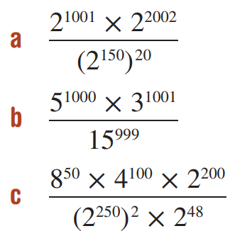  8 | 45 | 4

- Evaluate the following expression.
$$-{\left(\frac{2}{3}\right)}^{0}×{\left(-2\right)}^{2}×{\left({\left(2\right)}^{3}\right)}^{3}÷{\left(4\right)}^{2}$$

$$-128$$
- Using a calculator, evaluate ${\left(2^{3}\right)}^{4}$ and ${\left(2^{6}\right)}^{2}.$ ……………
4096
  - Explain why they are the same
The bases are the same, and $3×4=6×2$
  - Which of the following are also equal to ${\left(2^{3}\right)}^{4}$?

A, B, C
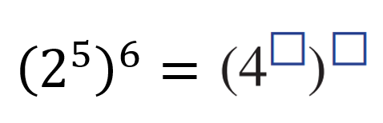
- Fill in the blanks in as many ways as possible.

Many possible answers, as long as the two numbers multiply to make 30
- Determine $x$
$${\left(5^{7}\right)}^{x}=5^{x}×5^{4}$$

$$x=\frac{2}{3}$$

HCF and LCM using Prime Factorisation

- Dot Operator for Multiplication
- Before we begin, we will introduce new notation to make writing multiplication neater.
- The dot product operator $⋅$ will show multiplication from now on.

$$5×7→5⋅7$$

- HCF and LCM on a Calculator
A calculator can find the HCF and LCM of two numbers. Use this to check answers.
FX-82 AU
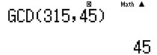

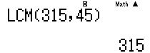

FX-8200 AU
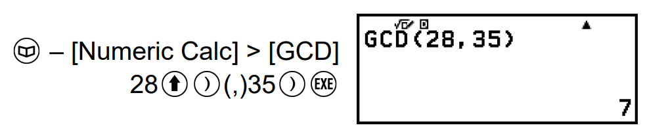

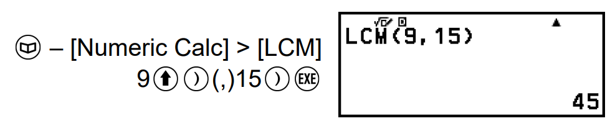

A calculator can also find the prime factorisation of a number.
FX-82 AU FX-8200 AU
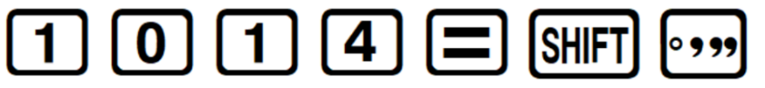
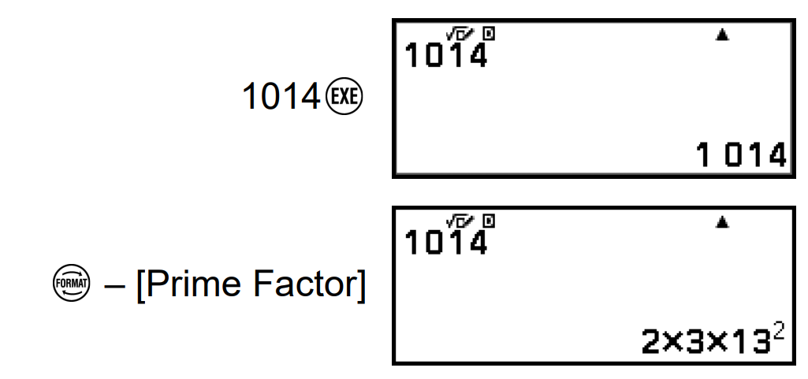

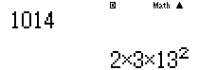

- HCF (or GCD) using Prime Factorisation
GCD (or HCF) of two numbers is the minimum of the indices of their prime factorisations.
To find the HCF of any two numbers:
- Express each number as a product of its prime factors
- List all unique prime factors - use a zero power for any prime not shared between numbers.
- Choose the smallest power for each prime factor and multiply them to find the HCF

- Example Find HCF using prime factorisation
Find the HCF of 294 and 364.
1. Prime factorisations
$294=2^{1}⋅3^{1}⋅7^{2}$
$364=2^{2}⋅7^{1}⋅{13}^{1}$
2. List unique prime factors, lining up the bases
$294=2^{1}⋅3^{1}⋅7^{2}⋅{13}^{0}$
$364=2^{2}⋅3^{0}⋅7^{1}⋅{13}^{1}$
3. Choose smallest powers for each factor
$294=2^{1}⋅3^{1}⋅7^{2}⋅{13}^{0}$
$364=2^{2}⋅3^{0}⋅7^{1}⋅{13}^{1}$

$HCF\left(294,364\right)=$ $2^{1}⋅3^{0}⋅7^{1}⋅{13}^{0}$
$=14$

- Guided Practice
Determine the HCF, based on these prime factorisations.
- $735=3⋅5⋅7^{2}$  $98=2⋅7^{2}$  49 | - $360=2^{3}⋅3^{2}⋅5$  $$700=2^{2}⋅5^{2}⋅7$$  20 | - $330=2⋅3⋅5⋅11$  $$27370=2⋅5⋅7⋅17⋅23$$  10
- $720=2^{4}⋅3^{2}⋅5$  $1080=2^{3}⋅3^{3}⋅5$  360 | - $3150=2⋅3^{2}⋅5^{2}⋅7$  $$4725=3^{3}⋅5^{2}⋅7$$  1575 | - $15470=2⋅5⋅7⋅13⋅17$  $$17640=2^{3}⋅3^{2}⋅5⋅7^{2}$$  70

- LCM using Prime Factorisation
LCM of two numbers is the maximum of the indices of their prime factorisations.
To find the LCM of any two numbers:
- Express each number as a product of its prime factors
- List all unique prime factors - use a zero power for any prime not shared between numbers.
- Choose the largest power for each prime factor and multiply them to find the LCM

- Example Find HCF using prime factorisation
Find the LCM of 294 and 364.
$294=2^{1}⋅3^{1}⋅7^{2}⋅{13}^{0}$
$364=2^{2}⋅3^{0}⋅7^{1}⋅{13}^{1}$
$LCM\left(294,364\right)=$ $2^{2}⋅3^{1}⋅7^{2}⋅{13}^{1}$
$=7644$

- Guided Practice
Determine the LCM, based on these prime factorisations.
- $30=2⋅3⋅5$  $70=2⋅5⋅7$  210 | - $39=3⋅13$  $$2366=2⋅7⋅{13}^{2}$$  7098 | - $735=3⋅5⋅7^{2}$  $$98=2⋅7^{2}$$  1470
- $210=2⋅3⋅5⋅7$  $294=2⋅3⋅7^{2}$  1470 | - $1274=2⋅7^{2}⋅13$  $$273=3⋅7⋅13$$  3822 | - $1547=7⋅13⋅17$  $$4420=2^{2}⋅5⋅13⋅17$$  30940

Foundation
- Write each pair of numbers as their prime factors and hence determine the HCF and LCM.
Check your answer using a calculator.
- 315 and 90  HCF: 45, LCM: 630 | - 180 and 252  HCF: 36, LCM: 1260 | - 900 and 1620  HCF: 180, LCM: 8100
- 756 and 1008  HCF: 252, LCM: 3024 | - 1152 and 1728  HCF: 576, LCM: 3456 | - 2450 and 3675  HCF: 1225, LCM: 7350

Development
- For the following questions, use a calculator to find the prime factorisation.
  - Find the HCF and LCM of 123 552 and 234 360.

HCF: 216, LCM: 134 053 920
  - Find the HCF and LCM of 2760, 4140, and 4830.

HCF: 690, LCM: 57 960
  - Find the HCF and LCM of 1260, 1680, and 2520.

HCF: 420, LCM: 5040
- Notice that $2^{3}⋅3⋅5^{4}=15000$ with 3 trailing zeros.
$2^{5}⋅5^{2}⋅7=5600$ with 2 trailing zeros.
$2^{7}⋅5^{5}⋅{11}^{2}=48 400 000$ with 5 trailing zeros.
  - How can you tell the number of trailing zeros from the prime factorisation?
Explain why this works.

It is the number of factors of 10 (how many lots of $2×5$ there are)
as multiplying a number by 10 has the effect of “adding” a trailing zero to a number.
  - How many zeroes are on the end of $2^{100}⋅3^{40}⋅5^{80}$?

80
  - Without using your calculator, what is the last non-zero digit of $2^{7}⋅3^{2}⋅5^{5}$?

Remove all factors of 10
$$2^{2}×3^{2}=36$$
So, 6 is the last non-zero digit.

Challenge Exercise
- Express each of the following natural numbers as a product of prime numbers:
  - $2 × 3 × 4 × 5 × 6$

2⁴ × 3² × 5
  - $2² × 3² × 4² × 5² × 6²$

2⁸ × 3⁴ × 5²
  - $2² × 3³ × 4⁴ × 5⁵ × 6⁶$

2¹⁶ × 3⁹ × 5⁵
  - $9⁹ × 10¹⁰ × 11¹¹ × 12¹²$

$$2³⁴ × 3³⁰ × 5¹⁰ × 11¹¹$$
- Express each of the following natural numbers as a product of prime numbers.
Hence, find the square root of each number.
- 196  $$196 = 2^{2}× 7^{2},$$  $$\sqrt{196}= 2 × 7 = 14$$ | - 324  $$324 = 2^{2}× 3^{4},$$  $$\sqrt{324}= 2 × 3^{2}= 18$$
- 225  $$225 = 3^{2}× 5^{2},$$  $$\sqrt{225}= 3 × 5 = 15$$ | - 484  $$484 = 2^{2}× {11}^{2},$$  $$\sqrt{484}= 2 × 11 = 22$$

- Express each of the following natural numbers as a product of prime numbers. Hence, find the cube root of each number.
- 125  $$125 = 5^{3},$$  $$\sqrt[3]{125}= 5$$ | - 216  $$216 = 2^{3}× 3^{3},$$  $$\sqrt[3]{216}= 2 × 3 = 6$$
- 1728  $$1728 = 2^{6}× 3^{3},$$  $$\sqrt[3]{1728}= 2^{2}× 3 = 12$$ | - 3375  $$3375 = 3^{3}× 5^{3},$$  $$\sqrt[3]{3375}= 3 × 5 = 15$$

- Find the prime factorisations of 2475 and 165. Hence, simplify $\frac{2475}{165}$.
$$2475 = 3^{2}× 5^{2}× 11,$$
$$165 = 3 × 5 × 11$$
$$\frac{2475}{165}=\frac{3^{2}× 5^{2}× 11}{3 × 5 × 11}= 3 × 5 = 15$$

- Determine, if possible, the values of:
- $\sqrt[3]{-1}$  $$-1$$ | - $\sqrt{-25}$  Not real | - $\sqrt[3]{-27}$  $$-3$$
- $\sqrt[3]{-8}$  $$-2$$ | - $^{4}\sqrt{-81}$  Not real | - $^{5}\sqrt{-100 000}$  $$-10$$
- $^{5}\sqrt{-32}$  $$-2$$ | - $\sqrt[3]{-\frac{1}{8}}$  $$-\frac{1}{2}$$

- By writing out the first few square numbers, what digit(s) can square numbers never end in?

Squares of digits 0–9 end in: 0, 1, 4, 9, 6, 5, 6, 9, 4, 1.
Square numbers can never end in 2, 3, 7, or 8.

- For each of these expressions, $n$ is an integer. Decide whether the statements are true or false. Explain your answer.
  - $5n$ is divisible by 5.

True, as $5n$ is a multiple of 5.
  - $4n+1$ is divisible by 4.

False, a multiple of 4 plus 1 is not divisible by 4.
  - $4(n+1)$ is divisible by 4.

True, since n + 1 is a whole number, $4\left(n+1\right)$ is a multiple of 4.
  - $6n$ is divisible by 2.

True, any multiple of 6 is divisible by 2.
  - $n(n+1)$ is divisible by 2.

True, $n$ and $n+1$ are consecutive, so one of them must be even.

  - Find the prime factorisation of 108.
  - By considering the powers, explain why 108 has twelve factors.
108 = 2² × 3³
Every factor has the form $2^{a}× 3^{b}$ where a ∈ {0,1,2} and b ∈ {0,1,2,3}.
There are 3 choices for a and 4 for b, giving 3 × 4 = 12 factors.

  - Find the prime factorisation of 540.
  - Hence, show that 540 has twenty-four factors.

540 = 2² × 3³ × 5
Every factor has the form $2^{a}× 3^{b}× 5^{c}$ where $a ∈ \{0,1,2\}, b ∈ \{0,1,2,3\}, c ∈ \{0,1\}.$
Number of factors = 3 × 4 × 2 = 24.

- Tom is designing a card game. His deck must be able to be divided evenly between 2 to 6 players. What is the smallest number of cards that his deck could have?

LCM(2,3,4,5,6) = 60

- A teacher brings chocolates to distribute amongst the highest scorers in their class. If there are 2, 3, 4, 5, 6 or 7 top scorers in the class, then the chocolates can be divided without remainder. What is the smallest number of chocolates that the teacher could have brought to class?

LCM(2,3,4,5,6,7) = 420

- Find the greatest common divisor and the least common multiple of the numbers 48, 66 and 72.
3. 48 = 2⁴ × 3
66 = 2 × 3 × 11
72 = 2³ × 3²
GCD = $2×3=6$
LCM = $2^{4}×3^{2}×11=1584$
- Find the smallest four-digit number divisible by 2 and 3.

Divisible by 6: smallest four-digit multiple of 6 = 167 × 6 = 1002.
- Find the smallest four-digit number that is divisible by 5 and 9.

Smallest four-digit multiple of 45 = 45 × 23 = 1035.

- Explain why we can find the LCM of two numbers by multiplying them then dividing by the HCF.

For two numbers $a$ and $b$, $HCF × LCM = a × b$
So, $LCM=a×b÷HCF$
- Find the largest three-digit number divisible by both 6 and 7.

3 Divisible by 6 and 7 means divisible by 42.
999/42 = 23 r 33, so largest multiple = 23 × 42 = 966.
- Find the smallest number divisible by 3 whose digits are all 5.

Digit sum of $k$ fives = $5k$, divisible by 3 when $k = 3$. Answer: 555.
- Find the smallest number divisible by 9 whose digits are all 2.

Digit sum of $k$ twos = $2k$, divisible by 9 when $k = 9$. Answer: 222222222.

  - How many of the integers between 1 and 350 inclusive are not divisible by 5?
  - How many of the integers between 1 and 350 inclusive are not divisible by 5 or 7?

a) Multiples of 5 up to 350: 350 ÷ 5 = 70
Not divisible by 5: 350 − 70 = 280

b) Multiples of 7 up to 350: 350 ÷ 7 = 50
Multiples of both 5 and 7 (i.e. 35): 350 ÷ 35 = 10
Total divisible by 5 or 7, subtracting overlap: 70 + 50 – 10 = 110
Total not divisible by 5 or 7: 350 – 110 = 240
- If each of the following is a square number (the smallest one possible), find the value of $x$.
Note that in this case, $17x$ means $17×x$
  - $17x$
  - $12x$
  - $15x$
  - $16x$
  - $288x$

a) 17 is prime, so $x$ = 17. 17 × 17 = 289 = 17².
b) 12 = 2² × 3; need $x$ = 3. 12 × 3 = 36 = 6².
c) 15 = 3 × 5; need $x$ = 15. 15 × 15 = 225 = 15².
d) 16 = 2⁴; already a perfect square, so $x$ = 1.
e) 288 = 2⁵ × 3²; need $x$ = 2. 288 × 2 = 576 = 24².
- Find the smallest positive whole number $m$ such that $60m$ is a perfect square.

60 = 2²×3×5.
Need 3 and 5 for even powers
$$m = 3×5 = 15$$

  - Find the prime factorisation of 280.
  - Find the least positive integer $n$ for which $280n$ is a perfect square.
  - Find the least positive integer $n$ for which $\frac{280}{n}$ is a perfect square.

280 = 2³ × 5 × 7
Need all prime powers even, so we need an extra of each factor.
$n = 2 × 5 × 7 = 70$.
Divide out the odd-powered primes: $n = 2 × 5 × 7 = 70$,
$280÷70= 2²$, a perfect square.

  - Find the prime factorisation of 270.
  - Find the least positive integer n for which $270n$ is a perfect square.
  - Find the least positive integer n for which $\frac{270}{n}$ is a perfect square.

270 = 2 × 3³ × 5
Need all prime powers even: $n = 2 × 3 × 5 = 30$.
Divide out odd-powered primes: $n = 2 × 3 × 5 = 30$,
$270÷30=3^{2}$, a perfect square.

- Find the least natural number $n$ for which $\frac{3060}{n}$ is a perfect square.
$3060 = 2² × 3² × 5 × 17$.
Divide out odd-powered primes: $n = 5 × 17 = 85$.

- Find the least natural number $n$ for which $24n$ is a perfect cube.

24 = 2³ × 3. Need all prime powers divisible by 3:
2³ already fine, need 3² more. $n = 3² = 9$.

- Suppose that 210-unit square tiles are arranged without overlap into a rectangular shape.
  - What is the smallest perimeter that the rectangle can have?
  - Given that the perimeter of the rectangle is 62, find its dimensions.
210 = 2 × 3 × 5 × 7.
To solve this problem, you need to know that the smallest perimeter for a given area is a square.
So we need the side lengths to be as similar as possible.
Factor pairs: closest pair is 14 × 15. Smallest perimeter = 2(14+15) = 58 units.

Side lengths$a + b = 31$. Factor pair of 210 summing to 31: 10 and 21.
Dimensions: 10 × 21.

- Find the smallest four-digit number that has exactly three factors.

For a number to have odd factors, it must be a perfect square.
For it to have three factors, it must be a perfect square of a prime number.
Smallest four digit number is 1000, which is just over 30² = 900.
Test squares of primes: 31² = 961 < 1000, 37² = 1369 > 1000. Answer: 1369.

- A rectangle has dimensions 60 m × 66 m. It is to be tiled with square tiles of equal size.
What is the least number of tiles required?

Largest square tile has side = GCD(60,66) = 6 m.
Number of tiles = $\left(\frac{60}{6}\right)× \left(\frac{66}{6}\right)$ = 10 × 11 = 110.

- Find the smallest six-digit number divisible by 9.

Smallest six-digit number is 100 000 with digit sum 1.
00008 has digit sum 9.
Answer: 100008.
- Find the largest ten-digit number divisible by 4 and 9.

Largest ten-digit number is 9999999999. Last two digits must be divisible by 4: try 72.
9999999972 has digit sum = 9×8+7+2 = 81, divisible by 9.
Answer: 9999999972.

- Show that:
- $3 < \sqrt{10}< 4$  $$3^{2}= 9 < 10 < 16 = 4^{2},$$  $$therefore 3 < \sqrt{10}< 4.$$ | - $11 < \sqrt{130}< 12$  $${11}^{2}= 121 < 130 < 144 = {12}^{2},$$  $$therefore 11 < \sqrt{130}< 12.$$ | - $\frac{4}{3}< \sqrt{2}<\frac{3}{2}$  $${\left(\frac{4}{3}\right)}^{2}=\frac{16}{9}< 2 and {\left(\frac{3}{2}\right)}^{2}=\frac{9}{4}> 2,$$  $$therefore\frac{4}{3}< \sqrt{2}<\frac{3}{2}.$$
- $\frac{5}{3}< \sqrt{3}<\frac{7}{4}$  $${\left(\frac{5}{3}\right)}^{2}=\frac{25}{9}< 3 and {\left(\frac{7}{4}\right)}^{2}=\frac{49}{16}> 3,$$  $$therefore\frac{5}{3}< \sqrt{3}<\frac{7}{4}.$$ | - $2 < \sqrt[3]{10}< 3$  $$2^{3}= 8 < 10 < 27 = 3^{3},$$  $$therefore 2 < \sqrt[3]{10}< 3.$$ | - $1.2 < \sqrt{1.5}< 1.3$  $${1.2}^{2}= 1.44 < 1.5 < 1.69 = {1.3}^{2},$$  $$therefore 1.2 < \sqrt{1.5}< 1.3.$$
- What is the smallest non-zero multiple of 2, 4, 7 and 8 which is a square?

LCM of these numbers is $2^{3}×7$
So we need to add a factor of 2 and 7 to make it a perfect square.
$$2^{4}×7^{2}=784$$

  - Write 315 and 90 in index form.

$$315=3^{2}⋅5⋅7$$
$$90=2⋅3^{2}⋅5$$
  - Find the LCM and HCF of 315 and 90. Answer in index form.

HCF: $3^{2}⋅5$, LCM: $2⋅3^{2}⋅5^{2}⋅7$
  - Find the product of the LCM and HCF. Answer in index form.

$$2⋅3^{2}⋅5^{2}⋅7$$
  - Find the product of 315 and 90. Answer in index form.

$$2⋅3^{2}⋅5^{2}⋅7$$
  - Explain, using your knowledge of index laws, why the $HCF×LCM$ of two numbers is always equivalent to the product of the given numbers.
The product of two numbers is the sum of the indices of their prime factors.

The HCF is the minimum of the indices and LCM is the maximum of the indices.
If you multiply the HCF and LCM, then you are adding the maximum and the minimum indices of the original numbers.

Since there are only two numbers, the sum of the minimum and maximum is the same as the sum of the two numbers.
- Write down the smallest number which leaves a remainder of 1 when divided by:
  - 2, 3 and 5
  - 2, 3 and 7
  - 2, 5 and 9
  - 2, 3 and 4
  - 3, 5 and 12
  - 2, 3, 4 and 9

a) LCM(2,3,5) = 30; so 30 + 1 = 31
b) LCM(2,3,7) = 42; so 42 + 1 = 43
c) LCM(2,5,9) = 90; so 90 + 1 = 91
d) LCM(2,3,4) = 12; so 12 + 1 = 13
e) LCM(3,5,12) = 60; so 60 + 1 = 61
f) LCM(2,3,4,9) = 36; so 36 + 1 = 37

- I am thinking of two numbers and $▼$. When I divide by 7 it leaves a remainder of 4.
When I divide $▼$ by 7 it leaves a remainder of 5. Find the remainder when I divide $+▼$ by 7.

Let □ = 7a + 4 and ▼ = 7b + 5.
□ + ▼ = 7(a + b) + 9 = 7(a + b + 1) + 2.
Remainder is 2.

- Think of a number (greater than 0). Double it, add one, then multiply by 5.
  - The answer always ends in a 5. Explain why.
  - Strike off the 5, and the remaining number will be the original number. Explain why.
  - Choose a number. Triple, it, add 2, then triple the result. Then add the original to the result.
Prove that this number always ends in 6.

a) Let $x$ be the original number. $5\left(2x+1\right)=10x+5$. Units digit is always 5.

b) Striking off the 5 gives $\frac{10x + 5 - 5}{10}$ $= x.$

c) $3\left(3x + 2\right)+ x = 10x + 6$, always ends in 6.

- Is it possible to find a sequence of 3 consecutive numbers, all of which are prime?

No. Any sequence of three consecutive numbers will have a multiple of 2 and a multiple of 3.
The only exception could be {1, 2, 3}, since 2 and 3 are prime. But 1 is not prime, so no.
- Three different taps drip every 48 seconds, 72 seconds, and 108 seconds, respectively.
If they all drip at midday, then when do they next drip simultaneously?

48 = 2⁴ × 3,
72 = 2³ × 3²,
108 = 2² × 3³
LCM = 2⁴ × 3³ = 432 seconds = 7 minutes 12 seconds after midday.
Next simultaneous drip at 12:07:12.
- Avery, Bella and Charlotte start running around a circular track at the same time.
Avery takes 42 seconds to complete every lap, Bella takes 66 s and Charlotte takes 110 s.
How many seconds elapse before they pass the starting line at the same time?

LCM(42,66,110):
42 = 2 × 3 × 7
66 = 2 × 3 × 11
110 = 2 × 5 × 11
LCM = 2 × 3 × 5 × 7 × 11 = 2310 seconds.
- Find the digits $A$ and $B$ (where $A$ and $B$ are different) if:
  - $3A5B$ is divisible by 9.
  - $A382B$ is divisible by 36.
  - $A237B$ is divisible by 45.
a) Digit sum = 3 + A + 5 + B = 8 + A + B divisible by 9, so A + B = 1 or 10.
List of all pairs of A and B:
A: 0 1 1 2 3 4 6 7 8 9
B: 1 0 9 8 7 6 4 3 2 1

b) Divisible by 36 means divisible by both 4 and 9.
Divisible by 4: last two digits 2B divisible by 4, so B = 0, 4, or 8.
Divisible by 9: A + 3 + 8 + 2 + B = A + B + 13 divisible by 9, so A + B = 5 or 14.
If B = 0: A = 5 → 53820
If B = 4: A = 1 → 13824
If B = 8: A = 6 → 63828

c) Divisible by 45 means divisible by 5 and 9.
Divisible by 5: B = 0 or 5.
Divisible by 9: A + 2 + 3 + 7 + B = A + B + 12 divisible by 9, so A + B = 6 or 15.
If B = 0: A = 6 → 62370
If B = 5: A = 1 → 12375
- Find all four-digit numbers of the form $5AB6$ that are divisible by:
  - 9
  - 4 and 9
  - 4, 8 and 9
  - 2, 3, 4, 6, 8 and 9
a) 11 + A + B divisible by 9, so A + B = 7 or 16.
Solutions: 5076, 5166, 5256, 5346, 5436, 5526, 5616, 5706, 5796, 5886.

b) Divisible by 4: B6 divisible by 4, so B = 1, 3, 5, 7, or 9.
Combined with A + B = 7 or 16:
B = 1: A = 6 → 5616
B = 3: A = 4 → 5436
B = 5: A = 2 → 5256
B = 7: A = 0 → 5076 or A = 9 → 5976
B = 9: A = 7 → 5796
Solutions: 5616, 5436, 5256, 5076, 5976, 5796.

c) Additionally divisible by 8: AB6 divisible by 8.
Using solutions from part b):
5616: 616/8 = 77 ✓ → 5616
5436: 436/8 = 54.5 ✗
5256: 256/8 = 32 ✓ → 5256
5076: 076/8 = 9.5 ✗
5976: 976/8 = 122 ✓ → 5976
5796: 796/8 = 99.5 ✗

Solutions: 5616, 5256, 5976.

d) Divisible by 2,3,4,6,8,9 means divisible by lcm = 72, so same constraint as (c).
Solutions: 5616, 5256, 5976.

- If ABCD is divisible by 3, explain why BDAC is also divisible by 3.
Write down all other four-digit numbers that are also divisible by 3 using the same digits.
ABCD divisible by 3 means A + B + C + D divisible by 3.
Any rearrangement has the same digit sum, so all rearrangements are divisible by 3.
The 24 permutations of A, B, C, D are all divisible by 3:
ABDC, ACBD, ACDB, ADBC, ADCB,
BACD, BADC, BCAD, BCDA, BDCA,
CABD, CADB, CBAD, CBDA, CDAB, CDBA,
DABC, DACB, DBAC, DBCA, DCAB, DCBA, BDAC.

  - A three-digit number 34A is added to 522 and gives 87B. If 87B is divisible by 9, find the value of A and B.
  - A three-digit number 5A3 is added to 148 and gives 7B1. If 7B1 is divisible by 9, find the value of A and B.
a) 87B divisible by 9: 8 + 7 + B = 15 + B divisible by 9, so B = 3.
34A + 522 = 873, so A = 1.

b) 7B1 divisible by 9: 7 + B + 1 = 8 + B divisible by 9, so B = 1.
5A3 + 148 = 711, so A = 6.

- If $p$ is an integer and the numbers $1 + p$ and $1 + 4p$are divisible by 4 and 5 respectively, find the two smallest values of $p$ for which this happens.

$\frac{1 + p}{4}$ integer when $p$ = 3, 7, 11, 15, 19, 23, 27, 31…
$\frac{1 + 4p}{5}$ integer when $p$ = 1, 6, 11, 16, 21, 26, 31…
Two smallest values: $p$ = 11 and $p$ = 31.

- Find the value of the letters (all different) if the following numbers are square numbers.
(Do this without a calculator.)
  - 5AB9
  - 6CDE6
a) Root between 70 and 80. Last digit 9, so root ends in 3 or 7.
73² = 5329 → A = 3, B = 2
77² = 5929 → A = 9, B = 2

b) Root between 200 and 300. Last digit 6: root ends in 4 or 6.
246² = 60516 → C = 0, D = 5, E = 1
254² = 64516 → C = 4, D = 5, E = 1

- A number is greater than 48 squared and less than 49 squared. If 6 squared is one of its factors, and it is a multiple of 13, what is the number?
48² = 2304, 49² = 2401.
Need multiple of 36 and 13 between 2304 and 2401.
Consider 48 squared. 48² = 6² $×$ 8² = 36 × 64
test next multiple of 36: 2340. $\frac{2340}{13}$ $= 180$
2340 is the next multiple of 36 divisible by 13.

- Hoc knew that before he closed his novel, the product of the page numbers was 1190.
What were the two open pages?

Need to find two consecutive numbers that multiply to 1190.
$$n\left(n+1\right)=1190$$
Note that 30² = 900 and 40² = 1600, so the two pages must be in the 30s.
By guess and check: pages 34 and 35

- It is 7 p.m. now. What will the time be $23 999 999 996$ hours later?

Note that time repeats every 24 hours.
Consider that 2 399 9999 996 is 4 off a multiple of 24: 24 000 000 000
This is the same as 20 hours after 7 p.m. + 20 hours = 3 p.m.
- The product of two whole numbers is 10 000 000. Neither number is a multiple of 10.
What are the two numbers?
10000000 = 2⁷×5⁷. Neither factor multiple of 10 means the two numbers are $2^{7}$ and $5^{7}$
2⁷ = 128, 5⁷ = 78125.

- Find all three-digit numbers that are divisible by 2, and which also contain the digits 1, 2 and 3 exactly once.

Must end in 2 (only even digit). Remaining digits 1 and 3 in first two places: 132, 312.
- A three-digit number below is divisible by 3. Find all such numbers.
$$\left[2\right]\left[\right][3]$$

Number is $2d3$. Digit sum =$5+d$ divisible by 3, so $d$ = 1, 4, 7.
Answer: 213, 243, 273.
- A three-digit number below is divisible by 2 and 3. Find all such numbers.
$$\left[7\right]\left[5\right]\left[\right]$$

Number is $75d$. Last digit even: $d ∈ \{0,2,4,6,8\}.$ Digit sum = $12+d$ divisible by 3: $d ∈ \{0,3,6,9\}.$Intersection: $d = 0$ or 6.
Answer: 750, 756.
- A three-digit number below is divisible by 3 and 5. Find all such numbers.
$$\left[\right]\left[7\right]\left[\right]$$
Number is $a7b$, divisible by 15. Last digit 0 or 5; digit sum divisible by 3.
$b = 0: a+7$ divisible by 3 → $a$ = 2,5,8 → 270, 570, 870.
$b = 5: a+12$ divisible by 3 → $a$ = 3,6,9 → 375, 675, 975.
Answer: 270, 375, 570, 675, 870, 975.

- A three-digit number below is divisible by both 4 and 9. Find all such numbers.
$$\left[\right]\left[2\right]\left[\right]$$
Number is $a2b$, divisible by 36. Last two digits $2b$ divisible by 4: $b$ ∈ {0,4,8}.
Digit sum = $a+2+b$divisible by 9.
$b = 0: a+2$ divisible by 9 → $a$ = 7 → 720.
$b = 4: a+6$ divisible by 9 → $a$ = 3 → 324.
$b = 8: a+10$ divisible by 9 → $a$ = 8 → 828.
Answer: 720, 324, 828.

- A three-digit number below is divisible by 9 and 5. Find all such numbers.
$$\left[\right]\left[8\right]\left[\right]$$
Number is a8b, divisible by 45. Last digit 0 or 5; digit sum divisible by 9.
$b = 0: a+8$divisible by 9 → $a$ = 1 → 180.
$b = 5: a+13$ divisible by 9 → $a$ = 5 → 585.
Answer: 180, 585.

- A four-digit number below is divisible by 5 and 9. Find all such numbers.
$$\left[\right]\left[9\right]\left[9\right]\left[\right]$$
Number is $a99b$, divisible by 45. Last digit 0 or 5; digit sum = $a+18+b$ divisible by 9, so $a+b$ divisible by 9.
b = 0: a = 9 → 9990.
$b = 5: a+5$ divisible by 9 → a = 4 → 4995.
Answer: 9990, 4995.

- A three-digit number has identical digits and is divisible by 4. Find all such numbers.

Number is $ddd$.
Last two digits $dd = 11d$
divisible by 4: $d$ divisible by 4.
$d = 4 → 444$;
$d = 8 → 888$.

- Using only the digits 2 and 0, find the smallest number divisible by 3 and 5.

Must end in 0. Digit sum divisible by 3: need three 2s minimum.
Smallest: 2220.

- Find the smallest number that is divisible by 1, 2, 3, 4 and 5, and which only uses the digits 0 and 5.

LCM(1,2,3,4,5) = 60. Divisible by 60: divisible by 4 (last two digits), by 3 (digit sum), ends in 0.
Using only 0 and 5: end in 0, last two digits 00 (div by 4).
Need three 5s for digit sum divisible by 3. Smallest: 55500.
- Four different bells ring every $\frac{5}{4}$ seconds, $\frac{6}{5}$ seconds, $\frac{7}{6}$ seconds and $\frac{8}{7}$ seconds.
If all four bells ring at the same time, then how long is it before they next ring at the same time?
Hint: To find the LCM of fractions, do LCM of numerators divided by HCF of denominators.

$$\frac{LCM\left(5,6,7,8\right)}{GCD\left(4,5,6,7\right)}=\frac{840}{1}$$
= 840 seconds.
- Four different bells toll every $1\frac{1}{2}$ hours, $1\frac{1}{3}$hours, $1\frac{1}{4}$hours, and $1\frac{1}{5}$ hours.
All four bells toll at midday. At what time of day do they next toll simultaneously?

Convert: $\frac{3}{2},\frac{4}{3},\frac{5}{4},\frac{6}{5}$ hours.
$$\frac{LCM\left(3,4,5,6\right)}{GCD\left(2,3,4,5\right)}=\frac{60}{1}= 60 hours after midday$$
= midnight, two and a half days later.
- The least common multiple of two positive integers is 900 and their greatest common divisor is 30. What is the smallest possible value of their sum?

Let numbers be $30a$ and $30b$ with GCD(a,b) = 1 and $30ab$ = 900, so $ab$ = 30.
Coprime factor pairs of 30: (1,30),(2,15),(3,10),(5,6).
Corresponding sums: 930, 510, 390, 330. Smallest sum = 330.
- Find two natural numbers whose sum is 50 and whose least common multiple is 429.

429 = 3 × 11 × 13.
Try 11 and 39: LCM(11,39) = 429, sum = 50.
Answer: 11, 39.

- Find two natural numbers whose sum is 40 and whose greatest common divisor is 4.

Write numbers as $4a$ and $4b$ with GCD(a,b) = 1 and $a+b$ = 10.
Coprime pairs: (1,9),(3,7).
Numbers: 4 and 36, or 12 and 28.

- Find three positive integers whose sum is 30 and whose least common multiple is 770.

770 = 2 × 5 × 7 × 11.
Try 5, 11, 14: LCM = 770, sum = 30.
Answer: 5, 11, 14.

- Find the smallest whole number $n$ such that $\sqrt{2016n}$ is a whole number.

$$2016n=2^{5}×3^{2}×7×n$$
For a square root to be a whole number, it must be a perfect square.
So all the powers must be multiples of 2.
Smallest number for $n$ is $2×7=14$
$$2^{4}×7^{2}=784$$

- The HCF of two numbers, $a$ and $b$, is 12. The LCM is 180.
  - Explain why the two numbers can be written as $a=12x$ and $b=12y$,
where $x$ and $y$ are coprime (co-prime means two whole numbers have no common factors)

Since the HCF is 12, both numbers must be multiples of 12.
$x$ and $y$ are coprime, because if they shared a factor, the HCF would not be 12.
  - Explain why the product of the two numbers is $12×180.$

As established earlier, the product of any two numbers is the product of the HCF and LCM
  - Write an equation using parts a and b.

$$ab=2160$$
$$ab=144xy$$
  - Solve your equation in part c for possible whole number values of $x$ and $y$.

$$144xy=2160$$
$$xy=15$$
$x$ and $y$ could be: (1, 15) or (3, 5)
  - Hence find the unknown numbers $a$ and $b$ (there are two possible pairs)

$a=12,b= 180$ or
$a=36, b=60$
- The HCF of two numbers is 15, and the LCM is 420. Find the two numbers.
There are two possible pairs.

15, 420
60, 105
- The HCF of two numbers is 21, and the LCM is 2310. Find the possible two numbers.

21, 2310
42, 1155
105, 462
210, 231

- Find the smallest number which satisfies all of the conditions below. This number leaves:
- a remainder of 5 when divided by 6
- a remainder of 4 when divided by 5
- a remainder of 3 when divided by 4
- a remainder of 2 when divided by 3
- a remainder of 1 when divided by 2

Let the number be $N$. If you add 1 to $N$, it would be divisible by 2, 3, 4, 5, 6
LCM(2,3,4,5,6) = 60, so $N + 1$ = 60 and $N$ = 59.

  - When a certain number $p$ is divided by 98 the quotient is 53 and the remainder is 27. Without calculating $p$, find the quotient and the remainder when $p$ is divided by 49.
  - When a certain number $p$ is divided by 98 the quotient is 53 and the remainder is 77. Without calculating $p$, find the quotient and the remainder when $p$ is divided by 49.
  - When a certain number $p$ is divided by $b$ ($b$ is even) the quotient is $q$ and the remainder is $r$. Find the quotient and the remainder when $p$ is divided by $\frac{b}{2}$, where $r <$ $\frac{b}{2}$.
a) $p$ = 98 × 53 + 27
= 49 × 106 + 27.
Quotient 106, remainder 27.

b) $p$ = 98 × 53 + 77
= 49 × 106 + 77
= 49 × 107 + 28.
Quotient 107, remainder 28.

c) $p = bq + r =\frac{b}{2}\left(2q\right)+ r.$
Quotient $2q$, remainder $r$.

- A teacher multiplied the ages of all the students (all teenagers) in her class and came up with the number 15 231 236 267 520.
  - What is the prime factorisation of this number?
  - Use the prime factorisation to help you work out the number of students in the class, their ages and the number of students of each age.
Using a factor tree:
15 231 236 267 520 = 2⁹ × 3⁵ × 5 × 7³ × 13 × 17² × 19
Assign prime factors to teenager ages (13–19), using each prime exactly as many times as it appears:
Age | Factorisation | Students
13 | 13 | 1
14 | 2×7 | 3
15 | 3×5 | 1
16 | 2⁴ | 1
17 | 17 | 2
18 | 2×3² | 2
19 | 19 | 1
Total: 11 students
- What is the smallest whole number that satisfies all of the following conditions?
- Dividing by 7 gives a remainder of 4.
- Dividing by 8 gives a remainder of 5.
- Dividing by 9 gives a remainder of 6.
Adding 3 would make the number N divisible by 7, 8, 9.
N+3 = lcm(7,8,9) = 504, so N = 501

- If the four-digit number $8mn9$ is a perfect square, find the values of $m$ and $n$.
Perfect squares between 8009 and 8999 ending in 9.
Since 90² = 8100, we will test numbers around 90.
For a perfect square to end in 9 it must end in 3 or 7.
Test 87², 93², 97²
93² = 8649.
$$m=6, n=4$$
- The digits 1, 2, 3, 4 and 5 are each used once in the five-digit number $abcde$ such that the three-digit number $abc$ is divisible by 4, $bcd$ is divisible by 5, and $cde$ is divisible by 3.
Find the values of $a, b, c, d$and $e$.

$bcd$ divisible by 5, so $d=5$.
$bc$ divisible by 4, digits from {1,2,3,4}:
Case 1: $bc$ = 12, so $c$ = 2. The available digits for $a$ and $e$ are {3,4}
$c + d + e = 2 + 5 + e$ is a multiple of 3. This is not possible with $e$ = 3 or 4.
Case 2: $bc = 24$, so $c = 4$. The available digits for $a$ and $e$ are {1, 3}
$c + d + e = 4 + 5 + e$is a multiple of 3. So $e$ = 3 and $a$ = 1; the number is 12453
Case 3: $bc = 32$, so $c = 2$. The available digits for $a$ and $e$ are {1,4}
$c + d + e = 2 + 5 + e$ is a multiple of 3. This is not possible with $e = 1$ or 4.
So, the only possible answer is 12453

- Find the smallest whole number whose digits are all 0s and 1s that is divisible by
1, 2, 3, 4, 5, 6, 7, 8, 9, 10.

The last 3 digits must be a multiple of 8 and end in 0. Since we can only use 1s and 0s: 000
Digit sum must be a multiple of 9, so to minimise it would have 9 1 digits.
This number would satisfy every divisibility rule except 7, which we need to check using the algorithm,
Try 111 111 111 000 – not divisible by 7
Since this is the only possible 12 digit number with 9 1s and 3 trailing zeros, we need to move on to 13 digit numbers.
Starting with the smallest possible: 1 011 111 111 000 – still not divisible by 7
Continue checking 1 101 111 111 000, then 1 110 111 111 000 and so on. The answer is 1111011111000

- Consider that the two digit number $ab$ can be written as $10a+b$.
  - Explain why this number is divisible by 9 if the digit sum $a+b$ is divisible by 9.
$$10a+b=9a+a+b$$
Since $9a$ must be divisible by 9, for $10a+b$ to be divisible by 9,
$a+b$ (the digit sum) must be divisible by 9.
  - Extend the rule ‘a number is divisible by 9 if its digit sum is divisible by 9’ for a three digit number $abc$
$$100a+10b+c=99a+9b+a+b+c$$
Since $99a+9b$ must be divisible by 9, for $100a+10b+c$ to be divisible by 9,
$a+b+c$ (the digit sum) must be divisible by 9.

  - Does this work for all numbers? Explain why.

Consider an $n$-digit number with digits $d_{n}, d_{n-1}, n_{n-2}…d_{1},d_{0}$
The number can be written as $d_{n}×{10}^{n}+d_{n-1}×{10}^{n-1}…+d_{1}×{10}^{1}+d_{0}×{10}^{0}$

Since ${10}^{n}-1=9999…$, it is divisible by 9.
So therefore, the number can be written as
Any whole number with digits $d_{n}, d_{n-1}, …, d_{1}, d_{0}$ can be written as:
$$\left(d_{n}⋅ {10}^{n}\right)+\left(d_{n-1}⋅ {10}^{n-1}\right)+⋯ + d_{1}⋅{10}^{1} + d_{0}⋅{10}^{0}$$

We can split each product, for example $d_{n}⋅{10}^{n}=d_{n}⋅\left({10}^{n}-1\right)+d_{n}$
$\left({10}^{n}- 1\right)$ is always a multiple of 9 (e.g. 9, 99, 999, …). So:

$$d_{n}⋅{10}^{n}+⋯+d_{0}=\underset{\text{divisible by 9}}{\underbrace{d_{n}\left({10}^{n}-1\right)+⋯+d_{1}\left(10-1\right)}}+\underset{\text{digit sum}}{\underbrace{\left(d_{n}+d_{n-1}+⋯+d_{0}\right)}}$$

The first part is divisible by 9, so the whole number is divisible by 9 if and only if the digit sum is divisible by 9.
yes

- Find all pairs of integers m and n whose greatest common divisor is 18 and whose least common multiple is 720.

Write as $18a$ and $18b$ with $GCD(a,b) = 1$ and $18ab = 720$, so $ab = 40$.
Coprime factor pairs of 40: (1,40),(5,8).
Numbers: 18 and 720, or 90 and 144.

- The number 1234321 is called a palindrome because it reads the same forward as it does backwards.
  - Find all three-digit palindromes divisible by 9.
  - Find all four-digit palindromes divisible by 3 and 5.
  - Find the smallest five-digit palindrome divisible by 4.
  - Find the largest five-digit palindrome divisible by 5.
  - Find the largest five-digit palindrome divisible by 4.
  - Find the smallest five-digit palindrome divisible by 4 and 9.

a) Palindrome $aba$, digit sum $2a+b$ divisible by 9.
$$2a+b = 9: (a,b) = (1,7),(2,5),(3,3),(4,1) → 171, 252, 333, 414.$$
$$2a+b = 18: (a,b) = (5,8),(6,6),(7,4),(8,2),(9,0) → 585, 666, 747, 828, 909.$$
$$2a+b = 27: (a,b) = (9,9) → 999.$$
Answer: 171, 252, 333, 414, 585, 666, 747, 828, 909, 999.

b) Palindrome $abba$, divisible by 15. Last digit $a = 5 (a ≠ 0).$
Digit sum = $10+2b$ divisible by 3, so $b = 1,4,7.$
Answer: 5115, 5445, 5775.

(c) Palindrome $abcba$, divisible by 4. Last two digits $ba$ divisible by 4.
Smallest: minimise $a$ then $b$. a = 2, b = 1: last two digits 12
Let $c = 0$ (smallest): 21012

d) Last digit = first digit = 5 (must end in 5 for divisibility by 5, and $a ≠ 0$).
Largest: $a = 5, b = 9, c = 9$ → 59995.

e) Last two digits $ba$ divisible by 4.
Maximise: Let $a = 8: b8$ divisible by 4 for even $b$; largest $b =$ 8 → 88.
Answer: 88988.

f) Divisible by 4 and 9. From (c), smallest palindrome divisible by 4 with $a = 2, b = 1$
Digit sum = $2(2)+2(1)+c = 6+c$ divisible by 9, $c = 3$
Number: 21312

- [UKMT IMO]:
Find the smallest positive integer which consists only of 0s and 1s and which is divisible by 12.

Divisible by 12 means divisible by 3 and 4.
Last two digits must be divisible by 4.
Digits must add to a multiple of 3.
11100
- [UKMT JMO]:
Every digit of a given positive integer is either a 3 or a 4 with each occurring at least once.
The integer is divisible by both 3 and 4. What is the smallest such integer?

The number must end in 44 to be divisible by 4.
The smallest possible integer (by systematically listing out all possibilities) is 3444
- [UKMT JMO]:
The eight-digit number “ppppqqqq”, where p and q are digits, is a multiple of 15.
What are all the possible numbers?

Multiple of 15 must be divisible by 3 and 5.
q must be 0 or 5.
Consider pppp5555, sum of digits 4p + 20 must be a multiple of 3.
Possible numbers are 11115555, 44445555, 77775555
pppp0000, sum of digits 4p must be a multiple of 3.
Possible numbers are 33330000, 66660000, 99990000

- [UKMT JMO]:
Prove that this is always true: The sum of five consecutive integers is divisible by 15 if and only if the third number is a multiple of 3.

The sum of 5 consecutive integers is $\left(n-2\right)+\left(n-1\right)+n+\left(n+1\right)+\left(n+2\right)=5n$
For $5n$ to be divisible by 15, $n$ must be a multiple of 3,
therefore, the third number must be a multiple of 3.
- [UKMT IMO]:
A positive integer $N$ is written using only the digits 2 and 3, with each appearing at least once.
If $N$ is divisible by 2 and by 3, what is the smallest possible integer $N$?

Divisible by 2 means the last digit must be 2.
The digits must sum to a multiple of 3.
Smallest possible integer (by systematically listing out all possibilities) is 2232
- [UKMT IMO]:
A palindromic number is one which reads the same when its digits are reversed, for example 23832. What is the largest six-digit palindromic number which is exactly divisible by 15?

Let the number be $abccba$
To be divisible by 5, $a$ must be 5, since the number can’t start with 0.
$$5bccb5$$
The sum of digits $2b+2c+10$ is a multiple of 3.
By systematically listing out all possibilities, starting with the largest values of $b$ and $c$,
597795
- [UKMT IMO]:
Find the possible values of the digits $p$ and $q$, given that the five-digit number ‘$p543q$’ is a multiple of 36.
Hint: a number is divisible by 9 if its digits sum to a multiple of 9.

Multiple of 36 means it is divisible by 4 and 9
Last two digits must be a multiple of 4, so 32 or 36
The digits must sum to a multiple of 9.
For p5432: $p+14$ is a multiple of 9, so $p=4$
For p5436, $p+18$ is a multiple of 9, so $p=9$
So, $p=4, q=2$ or $p=9, q=6$

- The HCF of two numbers is 504
The LCM of two numbers is 66 528
What could the two numbers be?

504, 66528
1512, 22176
2016, 16632
3024, 11088
5544, 6048

- The GCD of three numbers is 30 and their LCM is 900.
Two of the numbers are 60 and 150.
  - By finding the prime factorisations of the GCD, LCM, 60, and 150, explain why the third number must have a factor of $3^{2}$.

$$60=2^{2}⋅3⋅5$$
$$150=2⋅3⋅5^{2}$$
GCD: $2⋅3⋅5$
LCM: $2^{2}⋅3^{2}⋅5^{2}$
Since the LCM has $3^{2}$, the third number must have $3^{2}$
  - By considering the GCD and your answer to part a, find the possibilities for the third number (there are four).

$$2⋅3^{2}⋅5=90$$
$$2^{2}⋅3^{2}⋅5=180$$
$$2⋅3^{2}⋅5^{2}=450$$
$$2^{2}⋅3^{2}⋅5^{2}=900$$
  - [alternate method]
    - What is the LCM of 60 and 150?

$$2^{2}⋅3⋅5^{2}=300$$
    - What factor is missing to get an LCM of 900?

$$3$$
    - Hence explain why the third number must be a multiple of 90 and a factor of 900.

The third number must be a multiple of 90 to have the $3^{2}$ factor
It must be a factor of 900 to ensure the LCM doesn’t exceed 900

    - Therefore, find the possibilities for the third number.
$$90, 180, 450, 900$$

- The GCD of three numbers is 84 and their LCM is 205 800.
Two of the numbers are 1176 and 2100. What could the third number be?

Third number must have factors of $7^{3}$ and $3^{1}$
It can have either $2^{2 or 3}$ or $5^{0 1 or 2}$
4116
8232
20 580
41 160
102 900
205 800

- Mr Ding asked ChatGPT for a good exam question. It said:
“The GCD of three numbers is 42 and their LCM is 16 800.
Two of the numbers are 294 and 210. What could the third number be?”
He tried to work it out but found that this question is impossible. Explain why.

HCF: $42=2⋅3⋅7$
LCM: $16 800=2^{5}⋅3⋅5^{2}⋅7$
$$294=2⋅3⋅7^{2}$$
$$210=2⋅3⋅5⋅7$$
By looking at the prime factorisations, 16 800 is not divisible by 294,
so, it is impossible for the LCM of a set of numbers including 294 to be 16 800

